18/11/2018

Dhaka University Physical Education Center Digitalization

Software Test Plan and Test Case Design Report

**Dhaka University Physical Education Center Digitalization**

Software Test Plan and Test Case Design Report

**Submitted To**

Nadia Nahar

Institute of Information Technology

University of Dhaka

**Submitted By**

Tulsi Chandra Das - BSSE0811

Shuvradeb Saha - BSSE0815

Suravi Akhter - BSSE0827

**Date: 18/11/2018**



Contents

Chapter 1: Test Planning 1

About the Project 1

Features to be tested 1

Features not to be tested 1

Approach 1

Item Pass Fail Criteria 2

Test Deliverables 2

Testing Tasks 2

Responsibilities 3

Scheduling 3

Risks and Contingencies 4

Testing cost 4

Chapter 2: Test Case Designing 5

Test design specification (Subsystem: Authentication) 5

Reference Use Cases (Subsystem: Authentication) 5

Test specifications (Subsystem: Authentication) 7

Test design specification (Subsystem: Game management) 26

Reference Use Cases (Subsystem: Game management) 27

Test specifications (Subsystem: Game management) 29

Test design specification (Subsystem: Communication management) 56

Reference Use Cases (Subsystem: Communication management) 56

Test specifications (Subsystem: Communication management) 56

Test design specification (Subsystem: Score management) 64

Reference Use Cases (Subsystem: Score management) 64

Test specifications (Subsystem: Score management) 66

**List of Tables**

Table 1: Test specifications of T1 11

Table 2: Test specifications of T2 12

Table 3: Test specifications of T3 13

Table 4: Test specifications of T4 14

Table 5: Test specifications of T5 15

Table 6: Test specifications of T6 16

Table 7: Test specifications of T7 17

Table 8: Test specifications of T8 18

Table 9: Test specifications of T9 19

Table 10: Test specifications of T10 20

Table 11: Test specifications of T11 21

Table 12: Test specifications of T12 22

Table 13: Test specifications of T13 23

Table 14: Test specifications of T14 24

Table 15: Test specifications of T15 25

Table 16: Test specifications of T16 25

Table 17: Test specifications of T17 26

Table 18: Test specifications of T18 26

Table 19: Test specifications of T19 27

Table 20: Test specifications of T20 27

Table 21: Test specifications of T21 28

Table 22: Test specifications of T22 28

Table 23: Test specifications of T23 29

Table 24: Test specifications of T24 29

Table 25: Test specifications of T25 33

Table 26: Test specifications of T26 34

Table 27: Test specifications of T27 35

Table 28: Test specifications of T28 36

Table 29: Test specifications of T29 37

Table 30: Test specifications of T30 38

Table 31: Test specifications of T31 38

Table 32: Test specifications of T32 39

Table 33: Test specifications of T33 39

Table 34: Test specifications of T34 40

Table 35: Test specifications of T35 40

Table 36: Test specifications of T36 41

Table 37: Test specifications of T37 41

Table 38: Test specifications of T38 42

Table 39: Test specifications of T39 42

Table 40: Test specifications of T40 43

Table 41: Test specifications of T41 44

Table 42: Test specifications of T42 45

Table 43: Test specifications of T43 46

Table 44: Test specifications of T44 47

Table 45: Test specifications of T45 48

Table 46: Test specifications of T46 49

Table 47: Test specifications of T47 50

Table 48: Test specifications of T48 51

Table 49: Test specifications of T49 51

Table 50: Test specifications of T50 52

Table 51: Test specifications of T51 53

Table 52: Test specifications of T52 54

Table 53: Test specifications of T53 55

Table 54: Test specifications of T54 56

Table 55: Test specifications of T55 57

Table 56: Test specifications of T56 58

Table 57: Test specifications of T57 58

Table 58: Test specifications of T58 59

Table 59: Test specifications of T59 60

Table 60: Test specifications of T60 61

Table 61: Test specifications of T61 62

Table 62: Test specifications of T62 63

Table 63: Test specifications of T63 64

Table 64: Test specifications of T64 65

Table 65: Test specifications of T65 66

Table 66: Test specifications of T66 67

Table 67: Test specifications of T67 70

Table 68: Test specifications of T68 70

Table 69: Test specifications of T69 71

Table 70: Test specifications of T70 72

Table 71Test specifications of T71 73

Table 72: Test specifications of T72 74

Table 73: Test specifications of T73 75

Table 74: Test specifications of T74 76

Table 75: Test specifications of T75 77

Table 76: Test specifications of T76 78

Table 77: Test specifications of T77 79

Table 78: Test specifications of T78 80

Table 79: Test specifications of T79 81

Table 80: Test specifications of T80 82

Table 81: Test specifications of T81 83

Table 82: Test specifications of T75 84

Table 83: Test specifications of T83 85

Table 84: Test specifications of T84 85

Table 85: Test specifications of T85 86

Table 86: Test specifications of T86 87

Table 87: Test specifications of T87 88

Table 88: Test specifications of T88 89

Table 89: Test specifications of T89 90

Table 90: Test specifications of T90 91

Table 91: Test specifications of T91 92

Table 92: Test specifications of T92 93

Table 93: Test specifications of T93 94

Table 94: Test specifications of T94 94

Table 95: Test specifications of T95 95

Table 96: Test specifications of T96 96

Table 97: Test specifications of T97 97

Table 98: Test specifications of T98 98

Table 99: Test specifications of T99 99

Table 100: Test specifications of T100 100

Table 101: Test specifications of T101 101

Table 102: Test specifications of T102 102

**List of Figures**

Figure 1: Use case level-1.1 (Authentication) 9

Figure 2: Use case level-1.1.1 (Account Recovery) 10

Figure 3: Use case level - 1.1.2 (Registration) 10

Figure 4: Use case level-1.2 (Game Management) 31

Figure 5: Use case level-1.2.1 (Swimming pool registration) 31

Figure 6: Use case level-1.2.2 (Fixture Management) 32

Figure 7: Use case level – 1.2.3 (Hall annual sport) 32

Figure 8: Use case level-1.2.4 (Field Reservation) 33

Figure 9: Use case level-1.3 (Communication Management) 60

Figure 10: Use case level-1.4 (Score management) 68

Figure 11: Use case level-1.4.1 (Cricket Match) 69

Figure 12: Use case level-1.4.2 (Athletic) 69

Figure 13: Use case level-1.4.3 (Volleyball) 69

# Chapter 1: Test Planning

**Test Item to be tested**

**Name:** Dhaka University Physical Education Center Digitalization

**Type:** Web Application

**Version:** 1.0

## About the Project

The Dhaka University Physical Education Center Digitalization provides a process to register in the system, fixture, maintaining account, providing roll based interface to the users, displaying update of fixtures and scores.

Main concerns of the project is-

* Registration of the executive officer
* Registration of the client(teacher, student)
* Authentication of users
* Profile management of the users
* Score update of all types of game
* Hall annual sports result management
* Fixture management
* Communication management between executive officer and user
* Field reservation management
* Sport participation management
* Swimming pool management
* Live update of game scores

## Features to be tested

1. Authentication
2. Game management
3. Communication management
4. Score management

## Features not to be tested

1. Mailing system

## Approach

Since our test item is a website, we will test it locally using the XAMPP server. We will divide the functionalities into modules and test each feature using **Black Box Testing**. The test cases will be prepared with **Robustness Testing**. The input specifications will be prepared using the specifications acquired from the SRS.

## Item Pass Fail Criteria

If 90% of the prepared tested cases pass, then we can consider the project as a whole to pass

## Test Deliverables

Our deliverable documents are:

1. **Test plan:** We have attached following points with the test plan-

* Introduction
* Test-Item to be tested
* Features to be tested
* Features not to be tested
* Approach
* Item Pass and Fail Criteria
* Test deliverables
* Testing tasks
* Responsibilities
* Scheduling
* Risks and contingencies
* Testing costs

1. **Test case specifications:** We have attached 102 test cases within our project scope. A test case specification has-

* Test case Specification Identifier
* Purpose
* Special Environmental
* Special Procedural Requirements
* Inter-case Dependencies
* Input Specifications
* Test Procedure
* Output Specifications

## Testing Tasks

**Preparing and setting up system environment:** Before executing the test cases we have to prepare the server, which is a local XAMPP server with an associated database.

**Tasks for test case**

The features will be divided into three modules of testing.

**Testing Authentication:** refers to executive officer, teacher and student registration, login and password reset process testing

**Testing Game Management:** refers to swimming pool, fixtures, hall annual sports, field reservation process testing

**Testing Communication Management System:** refers to sports participation applicant management for department

**Testing Score Management:** refers to score management process testing of all type of games

## Responsibilities

Our team consists of three members. So, all of us have high responsibilities in this project.

|  |  |
| --- | --- |
| **Member** | **Responsibilities** |
| Suravi Akhter | * Preparing test cases for Authentication System * Preparing test cases for score management * Managing test team * Preparing test plan |
| Shuvradeb Saha | * Preparing test cases for game management * Providing environmental need * Executing test plan * Preparing test plan |
| Tulsi Chandra Das | * Preparing test cases for communication management System * Executing test plan * Preparing test plan |

## Scheduling

Time estimation to perform testing task:

|  |  |  |
| --- | --- | --- |
| **Test Task** | **Estimated time (day)** | **Date** |
| Defining team responsibilities | 1 | (09/11/2018) – (10/11/2018) |
| Defining test plan | 2 | (10/11/2018) – (12/11/2018) |
| Preparing test case | 2 | (12/11/2018) – (14/11/2018) |
| Executing test case | 1 | (14/11/2018) – (15/11/2018) |
| Preparing report | 2 | (15/11/2018) – (17/11/2018) |

## Risks and Contingencies

For some risks of this project there are some changes and consequences in the plan-

**Time shortage:** There was lack of time to prepare the test plan and test case specifications.

**Test case amount:** The number of tests performed has been reduced.

**Defect amount:** The number of acceptable defects has been increased for less test case and limited scope.

## Testing cost

Cost of planning and designing the tests of this project is very small since it is a small academic project.

**Cost to support the environment:** Since it is web-based software, we need internet connection to support the environment. So, the cost is to maintain internet connection in order to continue the testing.

**Cost of executing the tests:** We did not need any executing test cost.

**Cost of recording and analyzing the test results:** In the testing procedure, we have prepared a test case specification and also a test plan for this Dhaka University Physical Education Center Automation system. So, it requires a good amount of cost for preparing the document and delivering the document.

# Chapter 2: Test Case Designing

## Test design specification (Subsystem: Authentication)

|  |  |  |  |  |
| --- | --- | --- | --- | --- |
| Serial No. | Functionality | Use case no. in SRS | Test cases | Status |
|  | Login to the system | 1.1 | T1, T2, T3, T4 | Pass |
|  | Register to the system | 1.1.2 | T5,T6,T7,T8,T9,T10,T11,  T12,T13,T14 | Bug found in T12,T13, T14 |
|  | View new user request | 1.1.2 | T15 | Pass |
|  | Approve new user | 1.1.2 | T16 | Pass |
|  | Select forget password option | 1.1.1 | T17 | Pass |
|  | Request recovery code | 1.1.1 | T18,T19 | pass |
|  | Entering recovery code | 1.1.1 | T20,T21 | pass |
|  | Entering new password | 1.1.1 | T22, T23 | pass |
|  | Logout from the system | 1.1 | T24 | pass |

## Reference Use Cases (Subsystem: Authentication)

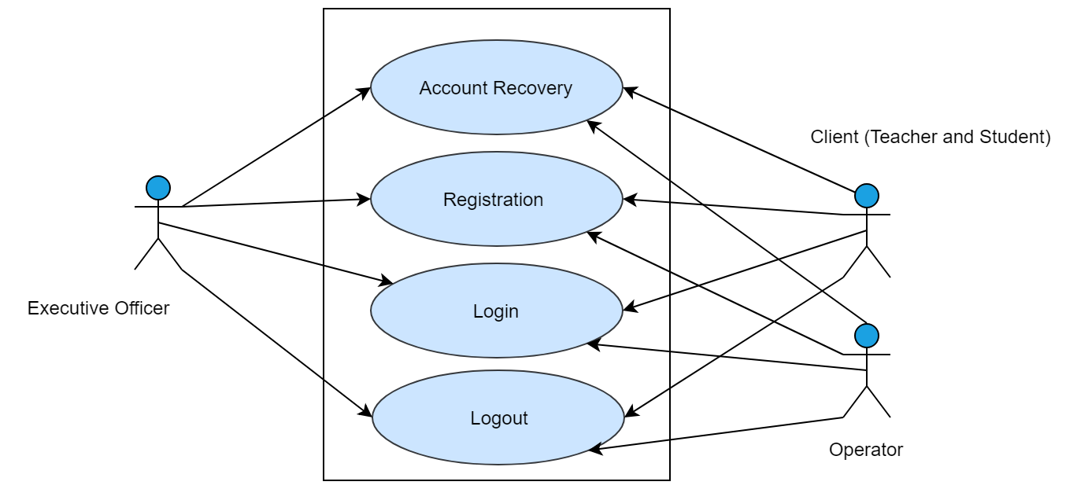

Figure 1: Use case level-1.1 (Authentication)

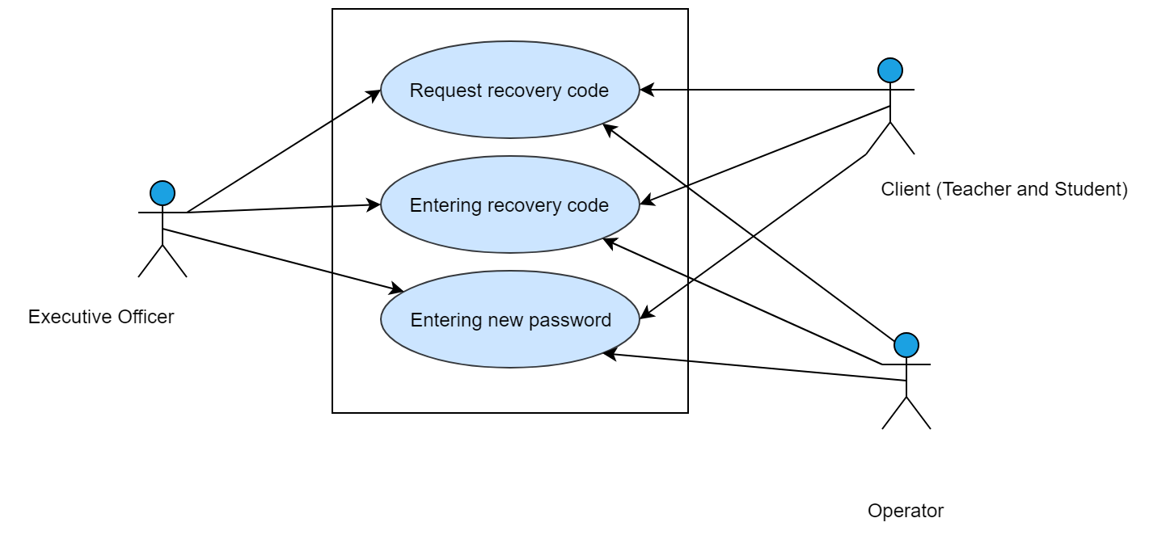

Figure 2: Use case level-1.1.1 (Account Recovery)

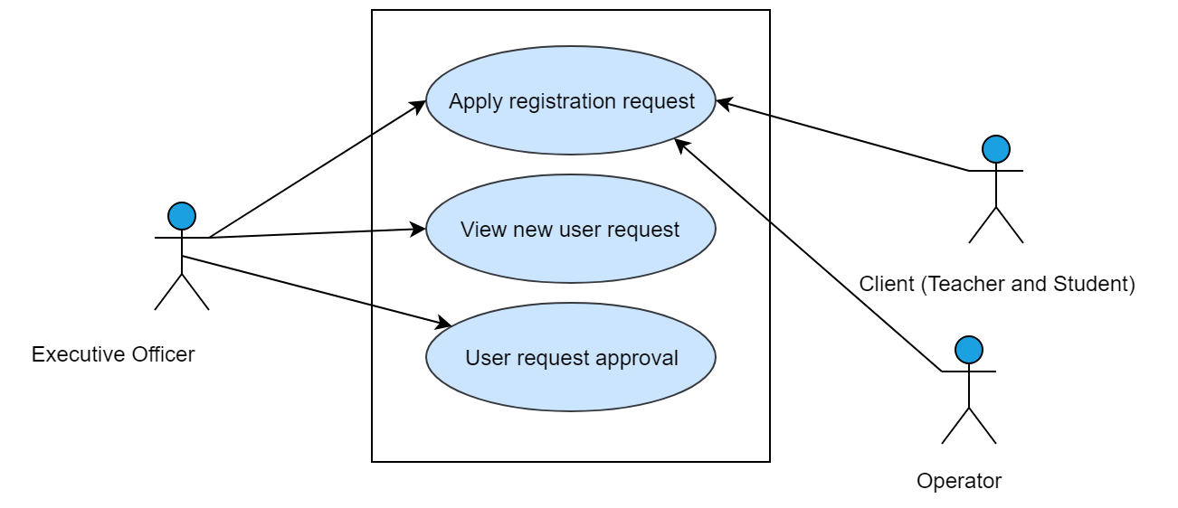

Figure 3: Use case level - 1.1.2 (Registration)

## Test specifications (Subsystem: Authentication)

Table 1: Test specifications of T1

|  |  |
| --- | --- |
| **Test case Specification Identifier** | T1 |
| **Purpose** | To check the functionality of ‘Login the system’ |
| **Test Items Needed** | Refer Usecase-1.1 in SRS |
| **Special Environmental** | Internet should be in working condition. Database software through which the data will be matched should be in running condition. |
| **Special Procedural Requirements** | - |
| **Inter-case Dependencies** | - |
| **Input Specifications** | Enter email and  password within 5 to 15 characters as given below:  tulshidas37@gmail.com  iit123 |
| **Test Procedure** | Choose ‘Sign in’ option  Enter user name and password and then press ‘Login’ button |
| **Expected Output Specifications** | User logged in and view user home page |
| **Actual Output** | User logged in and view user home page |

Table 2: Test specifications of T2

|  |  |
| --- | --- |
| **Test case Specification Identifier** | T2 |
| **Purpose** | To check the functionality of ‘Login the system’ |
| **Test Items Needed** | Refer Usecase-1.1 in SRS |
| **Special Environmental** | Internet should be in working condition. Database software through which the data will be matched should be in running condition. |
| **Special Procedural Requirements** | - |
| **Inter-case Dependencies** | - |
| **Input Specifications** | Enter Username within 5 to 30 characters  (user name is not in the database) and  Enter password within 5 to 15 characters as given below:  Rahim Uddin  Kalam Khan  iit123 |
| **Test Procedure** | Choose ‘Sign in’ option  Enter user name and password and then press ‘Login’ button |
| **Expected Output Specifications** | Show invalid username alert and show this one is not registered member |
| **Actual Output** | Show invalid username alert and show this one is not registered member |

Table 3: Test specifications of T3

|  |  |
| --- | --- |
| **Test case Specification Identifier** | T3 |
| **Purpose** | To check the functionality of ‘Login the system’ |
| **Test Items Needed** | Refer Usecase-1.1 in SRS |
| **Special Environmental** | Internet should be in working condition. Database software through which the data will be matched should be in running condition. |
| **Special Procedural Requirements** | - |
| **Inter-case Dependencies** | - |
| **Input Specifications** | Enter Username within 5 to 30 characters and  Enter password within 5 to 15 characters  (password does not match in the database)  as given below:  Nadia Nahar  Hello1111 |
| **Test Procedure** | Choose ‘Sign in’ option  Enter user name and password and then press ‘Login’ button |
| **Expected Output Specifications** | Show wrong password alert and provide options to recover password |
| **Actual Output** | Show wrong password alert and provide options to recover password |

Table 4: Test specifications of T4

|  |  |
| --- | --- |
| **Test case Specification Identifier** | T4 |
| **Purpose** | To check the functionality of ‘Login the system’ |
| **Test Items Needed** | Refer Usecase-1.1 in SRS |
| **Special Environmental** | Internet should be in working condition. Database software through which the data will be matched should be in running condition. |
| **Special Procedural Requirements** | - |
| **Inter-case Dependencies** | - |
| **Input Specifications** | Enter Username within 5 to 30 characters  (username does not match in the database) and  Enter password within 5 to 15 characters  (password does not match in the database)  as given below:  Nadia Nahar  Hello1111 |
| **Test Procedure** | Choose ‘Sign in’ option  Enter user name and password and then press ‘Login’ button |
| **Expected Output Specifications** | Show wrong password and user name alert |
| **Actual Output** | Show wrong password and user name alert |

Table 5: Test specifications of T5

|  |  |
| --- | --- |
| **Test case Specification Identifier** | T5 |
| **Purpose** | To check the functionality of ‘Register to the system’ |
| **Test Items Needed** | Refer Usecase-1.1.2 in SRS |
| **Special Environmental** | Internet should be in working condition. Database software through which the data will be matched should be in running condition. User’s browser should be running properly. |
| **Special Procedural Requirements** | - |
| **Inter-case Dependencies** | - |
| **Input Specifications** | Name contain A-Z, a-z and space within 5 to 30 characters  Username contains any character within 5 to 15 character  Email = [a-z0-9._%+-]+@[a-z0-9.-]+\.[a-z]{2,3}$  Password contains any character within 5 to 15 character  Confirm password is same as password as given below:  Tulshi Das  tulshi [tulshidas37@gmail.com](mailto:tulshidas37@gmail.com)  iit123  iit123 |
| **Test Procedure** | Choose ‘Sign Up’ option  Enter user name and password and then press ‘Register’ button |
| **Expected Output Specifications** | Show success message |
| **Actual Output** | Show success message |

Table 6: Test specifications of T6

|  |  |
| --- | --- |
| **Test case Specification Identifier** | T6 |
| **Purpose** | To check the functionality of ‘Register to the system’ |
| **Test Items Needed** | Refer Usecase-1.1.2 in SRS |
| **Special Environmental** | Internet should be in working condition. Database software through which the data will be matched should be in running condition. User’s browser should be running properly. |
| **Special Procedural Requirements** | - |
| **Inter-case Dependencies** | - |
| **Input Specifications** | Name contain number, A-Z, a-z and space within 5 to 30 characters  Username contains any character within 5 to 15 character  Email = [a-z0-9._%+-]+@[a-z0-9.-]+\.[a-z]{2,3}$  Password contains any character within 5 to 15 character  Confirm password is same as password as given below:  Shaishab Saha 123  Shaishab  [sahashaishab@gmail.com](mailto:sahashaishab@gmail.com)  iit123  iit123 |
| **Test Procedure** | Choose ‘Sign Up’ option  Enter user name and password and then press ‘Register’ button |
| **Expected Output Specifications** | Show invalid name alert |
| **Actual Output** | Show invalid name alert |

**Table 7: Test specifications of T7**

|  |  |
| --- | --- |
| **Test case Specification Identifier** | T7 |
| **Purpose** | To check the functionality of ‘Register to the system’ |
| **Test Items Needed** | Refer Usecase-1.1.2 in SRS |
| **Special Environmental** | Internet should be in working condition. Database software through which the data will be matched should be in running condition. User’s browser should be running properly. |
| **Special Procedural Requirements** | - |
| **Inter-case Dependencies** | - |
| **Input Specifications** | Name contain A-Z, a-z and space less than 5 characters  Username contains any character within 5 to 15 character  Email = [a-z0-9._%+-]+@[a-z0-9.-]+\.[a-z]{2,3}$  Password contains any character within 5 to 15 character  Confirm password is same as password as given below:  Nipa  Suravi  [suravi.nipa@gmail.com](mailto:suravi.nipa@gmail.com)  Iit123  Iit123 |
| **Test Procedure** | Choose ‘Sign Up’ option  Enter user name and password and then press ‘Register’ button |
| **Expected Output Specifications** | Show invalid name alert |
| **Actual output** | Show invalid name alert |

Table 8: Test specifications of T8

|  |  |
| --- | --- |
| **Test case Specification Identifier** | T8 |
| **Purpose** | To check the functionality of ‘Register to the system’ |
| **Test Items Needed** | Refer Usecase-1.1.2 in SRS |
| **Special Environmental** | Internet should be in working condition. Database software through which the data will be matched should be in running condition. User’s browser should be running properly. |
| **Special Procedural Requirements** | - |
| **Inter-case Dependencies** | - |
| **Input Specifications** | Name contain A-Z, a-z and space greater than 30 characters  Username contains any character within 5 to 15 character  Email = [a-z0-9._%+-]+@[a-z0-9.-]+\.[a-z]{2,3}$  Password contains any character within 5 to 15 character  Confirm password is same as password as given below:  Nipaaa ssaaaaaaa aaaddd daaaaaa ddssa  Suravi  [nipa@gmail.com](mailto:nipa@gmail.com)  Iit123  Iit123 |
| **Test Procedure** | Choose ‘Sign Up’ option  Enter user name and password and then press ‘Register’ button |
| **Expected Output Specifications** | Show invalid name alert |
| **Actual Output** | Show invalid name alert |

Table 9: Test specifications of T9

|  |  |
| --- | --- |
| **Test case Specification Identifier** | T8 |
| **Purpose** | To check the functionality of ‘Register to the system’ |
| **Test Items Needed** | Refer Usecase-1.1.2 in SRS |
| **Special Environmental** | Internet should be in working condition. Database software through which the data will be matched should be in running condition. User’s browser should be running properly. |
| **Special Procedural Requirements** | - |
| **Inter-case Dependencies** | - |
| **Input Specifications** | Name contain A-Z, a-z and space within 5 to 30 characters  Username contains any character less than 5 character  Email = [a-z0-9._%+-]+@[a-z0-9.-]+\.[a-z]{2,3}$  Password contains any character within 5 to 15 character  Confirm password is same as password as given below:  Nipa Suravi  nipa  [nipa@gmail.com](mailto:nipa@gmail.com)  Iit123  Iit123 |
| **Test Procedure** | Choose ‘Sign Up’ option  Enter user name and password and then press ‘Register’ button |
| **Expected Output Specifications** | Show invalid user name alert |
| **Actual Output** | Show invalid user name alert |

Table 10: Test specifications of T10

|  |  |
| --- | --- |
| **Test case Specification Identifier** | T10 |
| **Purpose** | To check the functionality of ‘Register to the system’ |
| **Test Items Needed** | Refer Usecase-1.1.2 in SRS |
| **Special Environmental** | Internet should be in working condition. Database software through which the data will be matched should be in running condition. User’s browser should be running properly. |
| **Special Procedural Requirements** | - |
| **Inter-case Dependencies** | - |
| **Input Specifications** | Name contain A-Z, a-z and space within 5 to 30 characters  Username contains any character greater 15 character  Email = [a-z0-9._%+-]+@[a-z0-9.-]+\.[a-z]{2,3}$  Password contains any character within 5 to 15 character  Confirm password is same as password as given below:  Suravi  nipa@gmail.dfenmandmma  [nipa@gmail.com](mailto:nipa@gmail.com)  Iit123  Iit123 |
| **Test Procedure** | Choose ‘Sign Up’ option  Enter user name and password and then press ‘Register’ button |
| **Expected Output Specifications** | Show invalid user name alert |
| **Actual Output** | Show invalid user name alert |

Table 11: Test specifications of T11

|  |  |
| --- | --- |
| **Test case Specification Identifier** | T11 |
| **Purpose** | To check the functionality of ‘Register to the system’ |
| **Test Items Needed** | Refer Usecase-1.1.2 in SRS |
| **Special Environmental** | Internet should be in working condition. Database software through which the data will be matched should be in running condition. User’s browser should be running properly. |
| **Special Procedural Requirements** | - |
| **Inter-case Dependencies** | - |
| **Input Specifications** | Name contain A-Z, a-z and space within 5 to 30 characters  Username contains any characters within 5 to 15 character  Email ≠ [a-z0-9._%+-]+@[a-z0-9.-]+\.[a-z]{2,3}$  Password contains any character within 5 to 15 character  Confirm password is same as password as given below:  Suravi  nipa@gmail.dfenmandmma  [nipa@gmail.com.ehem](mailto:nipa@gmail.com.ehem)  Iit123  Iit123 |
| **Test Procedure** | Choose ‘Sign Up’ option  Enter user name and password and then press ‘Register’ button |
| **Expected Output Specifications** | Show invalid email alert |
| **Actual Output** | Show invalid email alert |

Table 12: Test specifications of T12

|  |  |
| --- | --- |
| **Test case Specification Identifier** | T12 |
| **Purpose** | To check the functionality of ‘Register to the system’ |
| **Test Items Needed** | Refer Usecase-1.1.2 in SRS |
| **Special Environmental** | Internet should be in working condition. Database software through which the data will be matched should be in running condition. User’s browser should be running properly. |
| **Special Procedural Requirements** | - |
| **Inter-case Dependencies** | - |
| **Input Specifications** | Name contain A-Z, a-z and space within 5 to 30 characters  Username contains any characters within 5 to 15 character  Email = [a-z0-9._%+-]+@[a-z0-9.-]+\.[a-z]{2,3}$  Password contains any character less than 5 character  Confirm password is same as password as given below:  Suravi  nipa@gmail.dfenmandmma  [nipa@gmail.com](mailto:nipa@gmail.com)  iit  iit |
| **Test Procedure** | Choose ‘Sign Up’ option  Enter user name and password and then press ‘Register’ button |
| **Expected Output Specifications** | Show invalid password alert |
| **Actual Output** | Show success message |

Table 13: Test specifications of T13

|  |  |
| --- | --- |
| **Test case Specification Identifier** | T13 |
| **Purpose** | To check the functionality of ‘Register to the system’ |
| **Test Items Needed** | Refer Usecase-1.1.2 in SRS |
| **Special Environmental** | Internet should be in working condition. Database software through which the data will be matched should be in running condition. User’s browser should be running properly. |
| **Special Procedural Requirements** | - |
| **Inter-case Dependencies** | - |
| **Input Specifications** | Name contain A-Z, a-z and space within 5 to 30 characters  Username contains any characters within 5 to 15 character  Email = [a-z0-9._%+-]+@[a-z0-9.-]+\.[a-z]{2,3}$  Password contains any character greater than 15 character  Confirm password is same as password as given below:  Suravi  nipa@gmail.dfenmandmma  [nipa@gmail.com](mailto:nipa@gmail.com)  iit2323g2u4g2u43u23ug43u2  iit2323g2u4g2u43u23ug43u2 |
| **Test Procedure** | Choose ‘Sign Up’ option  Enter user name and password and then press ‘Register’ button |
| **Expected Output Specifications** | Show invalid password alert |
| **Actual Output** | Show success message |

Table 14: Test specifications of T14

|  |  |
| --- | --- |
| **Test case Specification Identifier** | T14 |
| **Purpose** | To check the functionality of ‘Register to the system’ |
| **Test Items Needed** | Refer Usecase-1.1.2 in SRS |
| **Special Environmental** | Internet should be in working condition. Database software through which the data will be matched should be in running condition. User’s browser should be running properly. |
| **Special Procedural Requirements** | - |
| **Inter-case Dependencies** | - |
| **Input Specifications** | Name contain A-Z, a-z and space within 5 to 30 characters  Username contains any characters within 5 to 15 character  Email = [a-z0-9._%+-]+@[a-z0-9.-]+\.[a-z]{2,3}$  Password contains any character greater than 15 character  Confirm password does not match with password as given below:  Suravi  nipa@gmail.dfenmandmma  [nipa@gmail.com](mailto:nipa@gmail.com)  iit2323  iit23 |
| **Test Procedure** | Choose ‘Sign Up’ option  Enter user name and password and then press ‘Register’ button |
| **Expected Output Specifications** | Show password and confirm password didn’t match alert |
| **Actual Output** | Show success message |

Table 15: Test specifications of T15

|  |  |
| --- | --- |
| **Test case Specification Identifier** | T15 |
| **Purpose** | To check the functionality of ‘view user request option’ |
| **Test Items Needed** | Refer Usecase-1.1.2 in SRS |
| **Special Environmental** | Internet should be in working condition. Database software through which the data will be matched should be in running condition. User’s browser should be running properly. |
| **Special Procedural Requirements** | - |
| **Inter-case Dependencies** | - |
| **Input Specifications** | None |
| **Test Procedure** | Choose ‘view user request’ option and press ‘Action’ button |
| **Expected Output Specifications** | View requested user list |
| **Actual Output** | View requested user list |

Table 16: Test specifications of T16

|  |  |
| --- | --- |
| **Test case Specification Identifier** | T16 |
| **Purpose** | To check the functionality of ‘approve user request’ |
| **Test Items Needed** | Refer Usecase-1.1.2 in SRS |
| **Special Environmental** | Internet should be in working condition. Database software through which the data will be matched should be in running condition. User’s browser should be running properly. |
| **Special Procedural Requirements** | - |
| **Inter-case Dependencies** | - |
| **Input Specifications** | None |
| **Test Procedure** | Press ‘Approve’ button |
| **Expected Output Specifications** | Show success message |
| **Actual Output** | Show success message |

Table 17: Test specifications of T17

|  |  |
| --- | --- |
| **Test case Specification Identifier** | T17 |
| **Purpose** | To check the functionality of ‘forget password’ |
| **Test Items Needed** | Refer Usecase-1.1.1 in SRS |
| **Special Environmental** | Internet should be in working condition. Database software through which the data will be matched should be in running condition. User’s browser should be running properly. |
| **Special Procedural Requirements** | - |
| **Inter-case Dependencies** | - |
| **Input Specifications** | None |
| **Test Procedure** | Press ‘Forgot password’ button |
| **Expected Output Specifications** | Prompt user to enter user email |
| **Actual Output** | Prompt user to enter user email |

Table 18: Test specifications of T18

|  |  |
| --- | --- |
| **Test case Specification Identifier** | T18 |
| **Purpose** | To check the functionality of ‘request recovery code’ |
| **Test Items Needed** | Refer Usecase-1.1.1 in SRS |
| **Special Environmental** | Internet should be in working condition. Database software through which the data will be matched should be in running condition. User’s browser should be running properly. |
| **Special Procedural Requirements** | The function ‘Forgot password’ must be executed prior to the current test case. |
| **Inter-case Dependencies** | T17 test case must be executed prior to the current test case execution |
| **Input Specifications** | Enter user registered email as shown below-  nipa@gmail.com |
| **Test Procedure** | Press ‘Send mail’ button |
| **Expected Output Specifications** | Show success message |
| **Actual Output** | Show success message |

Table 19: Test specifications of T19

|  |  |
| --- | --- |
| **Test case Specification Identifier** | T19 |
| **Purpose** | To check the functionality of ‘request recovery code’ |
| **Test Items Needed** | Refer Usecase-1.1.1 in SRS |
| **Special Environmental** | Internet should be in working condition. Database software through which the data will be matched should be in running condition. User’s browser should be running properly. |
| **Special Procedural Requirements** | The function ‘Forgot password’ must be executed prior to the current test case. |
| **Inter-case Dependencies** | T17 test case must be executed prior to the current test case execution |
| **Input Specifications** | Enter user registered email (email is not exist in the database) as shown below-  nilaaa@gmail.com |
| **Test Procedure** | Press ‘Send mail’ button |
| **Expected Output Specifications** | Show invalid email alert message |
| **Actual Output** | Show invalid email alert message |

Table 20: Test specifications of T20

|  |  |
| --- | --- |
| **Test case Specification Identifier** | T20 |
| **Purpose** | To check the functionality of ‘entering recovery code’ |
| **Test Items Needed** | Refer Usecase-1.1.1 in SRS |
| **Special Environmental** | Internet should be in working condition. Database software through which the data will be matched should be in running condition. User’s browser should be running properly. |
| **Special Procedural Requirements** | The function ‘request recovery code’ must be executed prior to the current test case |
| **Inter-case Dependencies** | T18 test case must be executed prior to the current test case execution |
| **Input Specifications** | Enter recovery code as shown below-  23456 |
| **Test Procedure** | Press ‘verify’ button |
| **Expected Output Specifications** | Prompt user to enter new password |
| **Actual Output** | Prompt user to enter new password |

Table 21: Test specifications of T21

|  |  |
| --- | --- |
| **Test case Specification Identifier** | T21 |
| **Purpose** | To check the functionality of ‘entering recovery code’ |
| **Test Items Needed** | Refer Usecase-1.1.1 in SRS |
| **Special Environmental** | Internet should be in working condition. Database software through which the data will be matched should be in running condition. User’s browser should be running properly. |
| **Special Procedural Requirements** | The function ‘request recovery code’ must be executed prior to the current test case |
| **Inter-case Dependencies** | T18 test case must be executed prior to the current test case execution |
| **Input Specifications** | Enter recovery code(recovery code doesn’t match with sent code) as shown below-  23444 |
| **Test Procedure** | Press ‘verify’ button |
| **Expected Output Specifications** | Show invalid code alert |
| **Actual Output** | Show invalid code alert |

Table 22: Test specifications of T22

|  |  |
| --- | --- |
| **Test case Specification Identifier** | T22 |
| **Purpose** | To check the functionality of ‘entering new password’ |
| **Test Items Needed** | Refer Usecase-1.1.1 in SRS |
| **Special Environmental** | Internet should be in working condition. Database software through which the data will be matched should be in running condition. User’s browser should be running properly. |
| **Special Procedural Requirements** | The function ‘entering recovery code’ must be executed prior to the current test case |
| **Inter-case Dependencies** | T20 test case must be executed prior to the current test case execution |
| **Input Specifications** | Enter the new password within 5 to 15 character as given below-  Iiiiii123 |
| **Test Procedure** | Press ‘Set password’ button |
| **Expected Output Specifications** | Show success message |
| **Actual Output** | Show success message |

**Table 23: Test specifications of T23**

|  |  |
| --- | --- |
| **Test case Specification Identifier** | T23 |
| **Purpose** | To check the functionality of ‘entering new password’ |
| **Test Items Needed** | Refer Usecase-1.1.1 in SRS |
| **Special Environmental** | Internet should be in working condition. Database software through which the data will be matched should be in running condition. User’s browser should be running properly. |
| **Special Procedural Requirements** | The function ‘entering recovery code’ must be executed prior to the current test case |
| **Inter-case Dependencies** | T20 test case must be executed prior to the current test case execution |
| **Input Specifications** | Enter the new password less than 5 characters as given below-  nipa |
| **Test Procedure** | Press ‘Set password’ button |
| **Expected Output Specifications** | Show invalid password alert |
| **Actual Output** | Show invalid password alert |

Table 24: Test specifications of T24

|  |  |
| --- | --- |
| **Test case Specification Identifier** | T24 |
| **Purpose** | To check the functionality of ‘logout from the system’ |
| **Test Items Needed** | Refer Usecase-1.1 in SRS |
| **Special Environmental** | Internet should be in working condition. Database software through which the data will be matched should be in running condition. User’s browser should be running properly. |
| **Special Procedural Requirements** | - |
| **Inter-case Dependencies** | - |
| **Input Specifications** | none |
| **Test Procedure** | Press ‘logout’ button |
| **Expected Output Specifications** | User logged out and show external home page |
| **Actual Output** | User logged out and show external home page |

## Test design specification (Subsystem: Game management)

|  |  |  |  |  |
| --- | --- | --- | --- | --- |
| Serial No. | Functionality | Use case no. in SRS | Test cases | Status |
|  | Register for swimming pool member | 1.2 | T25 | Pass |
|  | Apply for swimming pool member | 1.2.1 | T26, T27, T28, T29 | Pass |
|  | View student request for swimming pool member | 1.2.1 | T30 | Pass |
|  | Approve registration request for swimming pool member | 1.2.1 | T31 | Pass |
|  | Remove request for swimming pool member | 1.2.1 | T32 | Bug found in T32 |
|  | Search student request for swimming pool member | 1.2.1 | T33, T34 | Pass |
|  | Fixture management | 1.2 | T35 | Pass |
|  | Create announcement | 1.2.2 | T36 | Pass |
|  | Publish fixture announcement | 1.2.2 | T37 | Pass |
|  | Hall annual sport | 1.2 | T38 | Pass |
|  | Create list of winner and rank | 1.2.3 | T39, T40, T41, T42, T43, T44, T45, T46, T47 | Pass |
|  | View hall annual sport result | 1.2.3 | T48 | Pass |
|  | Field reservation | 1.2 | T49 | Pass |
|  | Apply for field reservation | 1.2.4 | T49, T50, T51, T52, T53, T54,T55 | Pass |
|  | View field reservation request | 1.2.4 | T56 | Pass |
|  | Approve field reservation request | 1.2.4 | T57 | Pass |
|  | Remove field reservation request | 1.2.4 | T58 | Pass |

## Reference Use Cases (Subsystem: Game management)

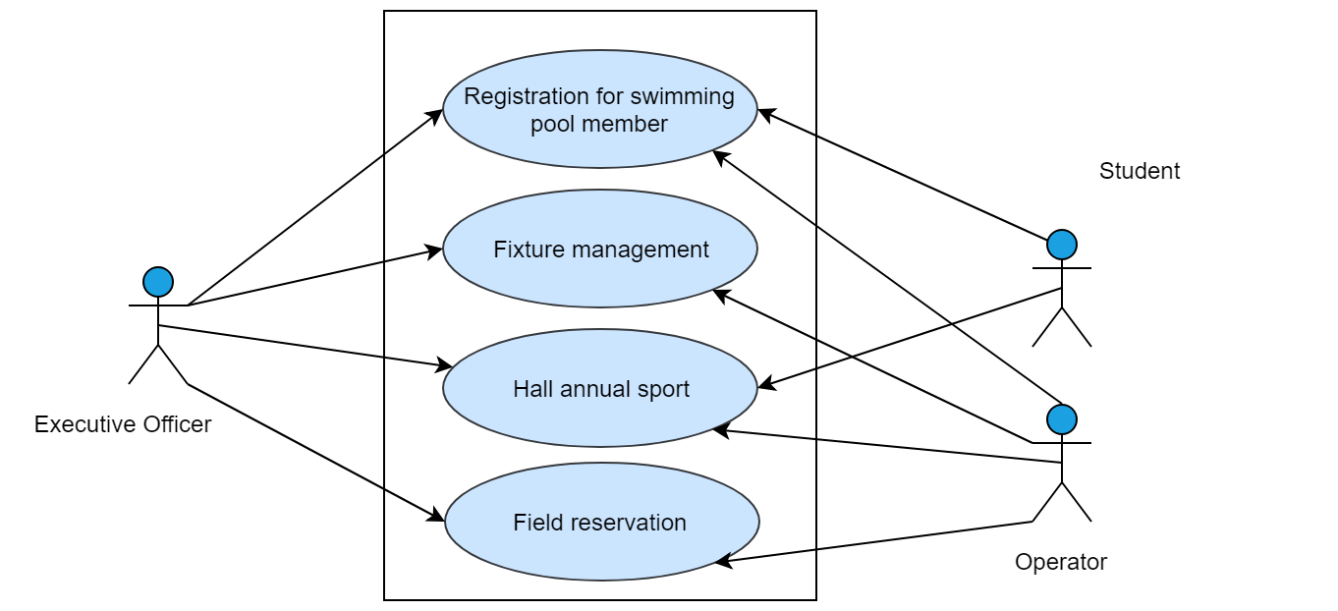

Figure 4: Use case level-1.2 (Game Management)

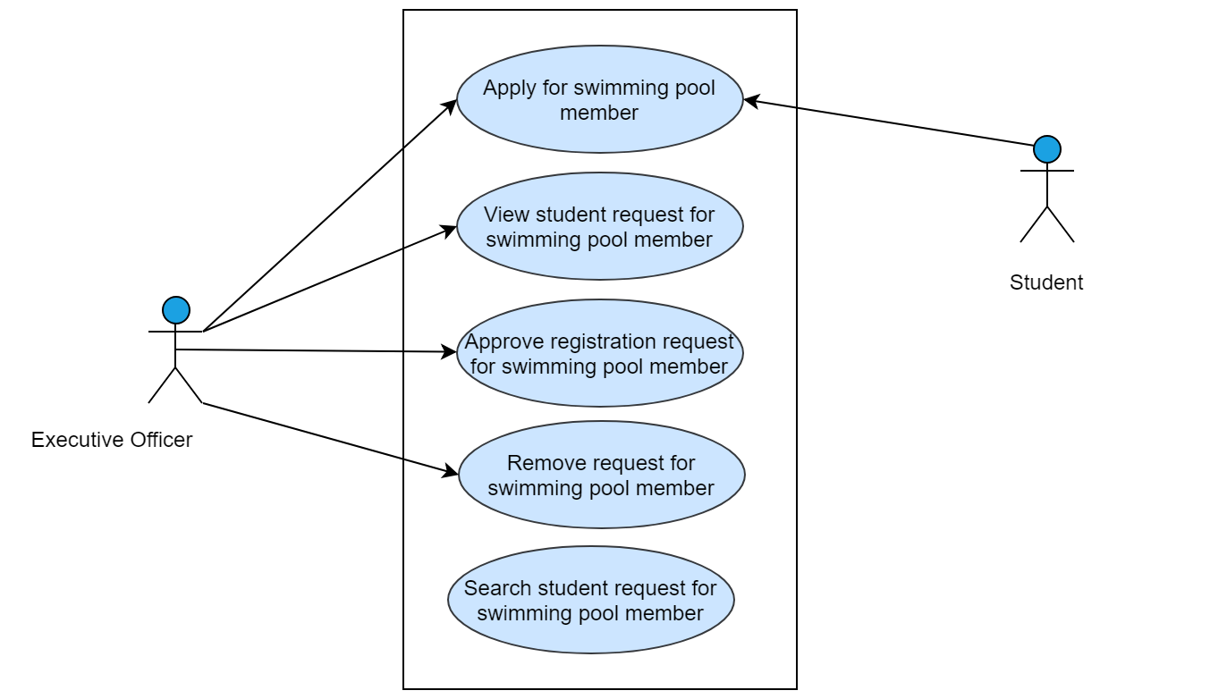

Figure 5: Use case level-1.2.1 (Swimming pool registration)

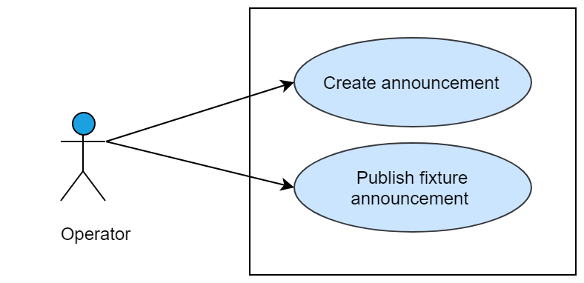

Figure 6: Use case level-1.2.2 (Fixture Management)

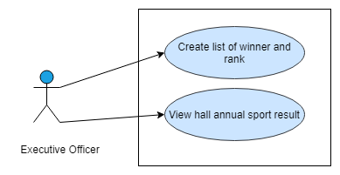

Figure 7: Use case level – 1.2.3 (Hall annual sport)

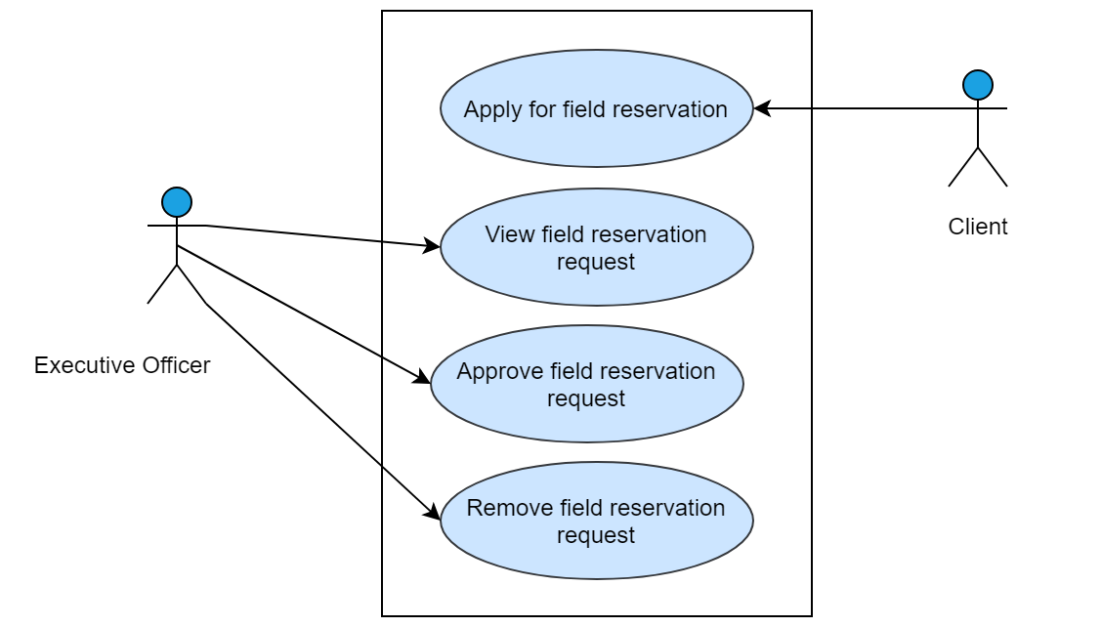

Figure 8: Use case level-1.2.4 (Field Reservation)

## Test specifications (Subsystem: Game management)

Table 25: Test specifications of T25

|  |  |
| --- | --- |
| **Test case Specification Identifier** | T25 |
| **Purpose** | To check the functionality of ‘Apply for swimming pool member’ |
| **Test Items Needed** | Refer Usecase-1.2 in SRS |
| **Special Environmental** | Internet should be in working condition. Database software through which the data will be matched should be in running condition. User’s browser should be running properly. |
| **Special Procedural Requirements** |  |
| **Inter-case Dependencies** | - |
| **Input Specifications** | none |
| **Test Procedure** | Press ‘Register to swimming pool’ button |
| **Expected Output Specifications** | Prompt user for giving registration data |
| **Actual Output** | Prompt user for giving registration data |

Table 26: Test specifications of T26

|  |  |
| --- | --- |
| **Test case Specification Identifier** | T26 |
| **Purpose** | To check the functionality of ‘Registration of swimming pool’ |
| **Test Items Needed** | Refer Usecase-1.2.1 in SRS |
| **Special Environmental** | Internet should be in working condition. Database software through which the data will be matched should be in running condition. User’s browser should be running properly. |
| **Special Procedural Requirements** | The function ‘Apply for swimming pool member’ must be executed prior to the current test case |
| **Inter-case Dependencies** | T25 test case must be executed prior to the current test case execution |
| **Input Specifications** | Name contains characters only within 5 to 30 characters, department contains characters only within 50 characters, year contains number and character only within 5 character and address contains characters only within 100 characters  As shown below-  Suravi Akhter  Software engineering  3rd  Sufia Kamal Hall, University of Dhaka |
| **Test Procedure** | Press ‘Sign Up’ button |
| **Expected Output Specifications** | Show success message |
| **Actual Output** | Show success message |

Table 27: Test specifications of T27

|  |  |
| --- | --- |
| **Test case Specification Identifier** | T27 |
| **Purpose** | To check the functionality of ‘Registration of swimming pool’ |
| **Test Items Needed** | Refer Usecase-1.2.1 in SRS |
| **Special Environmental** | Internet should be in working condition. Database software through which the data will be matched should be in running condition. User’s browser should be running properly. |
| **Special Procedural Requirements** | The function ‘Apply for swimming pool member’ must be executed prior to the current test case |
| **Inter-case Dependencies** | T25 test case must be executed prior to the current test case execution |
| **Input Specifications** | Name contains number , department contains characters only within 50 characters, year contains number and character only within 5 character and address contains characters only within 100 characters  As shown below-  Nipa123  Software engineering  3rd  Sufia Kamal Hall, University of Dhaka |
| **Test Procedure** | Press ‘Sign Up’ button |
| **Expected Output Specifications** | Show invalid name alert message |
| **Actual Output** | Show invalid name alert message |

Table 28: Test specifications of T28

|  |  |
| --- | --- |
| **Test case Specification Identifier** | T28 |
| **Purpose** | To check the functionality of ‘Registration of swimming pool’ |
| **Test Items Needed** | Refer Usecase-1.2.1 in SRS |
| **Special Environmental** | Internet should be in working condition. Database software through which the data will be matched should be in running condition. User’s browser should be running properly. |
| **Special Procedural Requirements** | The function ‘Apply for swimming pool member’ must be executed prior to the current test case |
| **Inter-case Dependencies** | T25 test case must be executed prior to the current test case execution |
| **Input Specifications** | Name contains characters only within 5 to 30 characters , department contains number, year contains number and character only within 5 character and address contains characters only within 100 characters  As shown below-  Suravi Akhter  Software engineering123  3rd  Sufia Kamal Hall, University of Dhaka |
| **Test Procedure** | Press ‘Sign Up’ button |
| **Expected Output Specifications** | Show invalid department name alert message |
| **Actual Output** | Show invalid department name alert message |

Table 29: Test specifications of T29

|  |  |
| --- | --- |
| **Test case Specification Identifier** | T29 |
| **Purpose** | To check the functionality of ‘Registration of swimming pool’ |
| **Test Items Needed** | Refer Usecase-1.2.1 in SRS |
| **Special Environmental** | Internet should be in working condition. Database software through which the data will be matched should be in running condition. User’s browser should be running properly. |
| **Special Procedural Requirements** | The function ‘Apply for swimming pool member’ must be executed prior to the current test case |
| **Inter-case Dependencies** | T25 test case must be executed prior to the current test case execution |
| **Input Specifications** | Name contains characters only within 5 to 30 characters , department contains character within 50 characters, year contains number and character only within 5 character and address contains number only  As shown below-  Suravi Akhter  Software engineering123  3rd  123343743827438 |
| **Test Procedure** | Press ‘Sign Up’ button |
| **Expected Output Specifications** | Show invalid address alert message |
| **Actual Output** | Show invalid address alert message |

Table 30: Test specifications of T30

|  |  |
| --- | --- |
| **Test case Specification Identifier** | T30 |
| **Purpose** | To check the functionality of ‘View student request for swimming pool member’ |
| **Test Items Needed** | Refer Usecase-1.2 .1in SRS |
| **Special Environmental** | Internet should be in working condition. Database software through which the data will be matched should be in running condition. User’s browser should be running properly. |
| **Special Procedural Requirements** | - |
| **Inter-case Dependencies** | - |
| **Input Specifications** | none |
| **Test Procedure** | Press ‘view request’ button |
| **Expected Output Specifications** | View requested user list |
| **Actual Output** | View requested user list |

Table 31: Test specifications of T31

|  |  |
| --- | --- |
| **Test case Specification Identifier** | T31 |
| **Purpose** | To check the functionality of ‘approve request for being swimming pool member’ |
| **Test Items Needed** | Refer Usecase-1.2.1 in SRS |
| **Special Environmental** | Internet should be in working condition. Database software through which the data will be matched should be in running condition. User’s browser should be running properly. |
| **Special Procedural Requirements** | The function ‘View student request for swimming pool member’ must be executed prior to the current test case |
| **Inter-case Dependencies** | T30 test case must be executed prior to the current test case execution |
| **Input Specifications** | none |
| **Test Procedure** | Press ‘approve’ button |
| **Expected Output Specifications** | Show success message |
| **Actual Output** | Show success message |

Table 32: Test specifications of T32

|  |  |
| --- | --- |
| **Test case Specification Identifier** | T32 |
| **Purpose** | To check the functionality of ‘remove request for being swimming pool member’ |
| **Test Items Needed** | Refer Usecase-1.2.1 in SRS |
| **Special Environmental** | Internet should be in working condition. Database software through which the data will be matched should be in running condition. User’s browser should be running properly. |
| **Special Procedural Requirements** | The function ‘View student request for swimming pool member’ must be executed prior to the current test case |
| **Inter-case Dependencies** | T30 test case must be executed prior to the current test case execution |
| **Input Specifications** | none |
| **Test Procedure** | Press ‘remove’ button |
| **Expected Output Specifications** | Show success message |
| **Actual Output** | Show error message |

Table 33: Test specifications of T33

|  |  |
| --- | --- |
| **Test case Specification Identifier** | T33 |
| **Purpose** | To check the functionality of ‘Search student request for swimming pool member’ |
| **Test Items Needed** | Refer Usecase-1.2.1 in SRS |
| **Special Environmental** | Internet should be in working condition. Database software through which the data will be matched should be in running condition. User’s browser should be running properly. |
| **Special Procedural Requirements** | The function ‘View student request for swimming pool member’ must be executed prior to the current test case |
| **Inter-case Dependencies** | T30 test case must be executed prior to the current test case execution |
| **Input Specifications** | Enter student name in search bar as shown below-  Suravi |
| **Test Procedure** | Press ‘search’ button |
| **Expected Output Specifications** | Show student information |
| **Actual Output** | Show student information |

Table 34: Test specifications of T34

|  |  |
| --- | --- |
| **Test case Specification Identifier** | T34 |
| **Purpose** | To check the functionality of ‘Search student request for swimming pool member’ |
| **Test Items Needed** | Refer Usecase-1.2.1 in SRS |
| **Special Environmental** | Internet should be in working condition. Database software through which the data will be matched should be in running condition. User’s browser should be running properly. |
| **Special Procedural Requirements** | The function ‘View student request for swimming pool member’ must be executed prior to the current test case |
| **Inter-case Dependencies** | T30 test case must be executed prior to the current test case execution |
| **Input Specifications** | Enter student name (isn’t in the database) in search bar as shown below-  nipa |
| **Test Procedure** | Press ‘search’ button |
| **Expected Output Specifications** | Show no student found message |
| **Actual Output** | Show no student found message |

Table 35: Test specifications of T35

|  |  |
| --- | --- |
| **Test case Specification Identifier** | T35 |
| **Purpose** | To check the functionality of ‘Fixture management’ |
| **Test Items Needed** | Refer Usecase-1.2 in SRS |
| **Special Environmental** | Internet should be in working condition. Database software through which the data will be matched should be in running condition. User’s browser should be running properly. |
| **Special Procedural Requirements** | - |
| **Inter-case Dependencies** | - |
| **Input Specifications** | none |
| **Test Procedure** | Press ‘Fixture management’ button |
| **Expected Output Specifications** | Prompt user for writing announcement |
| **Actual Output** | Prompt user for writing announcement |

Table 36: Test specifications of T36

|  |  |
| --- | --- |
| **Test case Specification Identifier** | T36 |
| **Purpose** | To check the functionality of ‘Create announcement’ |
| **Test Items Needed** | Refer Usecase-1.2.2 in SRS |
| **Special Environmental** | Internet should be in working condition. Database software through which the data will be matched should be in running condition. User’s browser should be running properly. |
| **Special Procedural Requirements** | - |
| **Inter-case Dependencies** | - |
| **Input Specifications** | Announcement contains characters only as shown below  Football tournament between SE and CSE will be held on 28th November, 2018. |
| **Test Procedure** | Check input field is not null |
| **Expected Output Specifications** | Show success message |
| **Actual Output** | Show success message |

Table 37: Test specifications of T37

|  |  |
| --- | --- |
| **Test case Specification Identifier** | T37 |
| **Purpose** | To check the functionality of ‘Publish announcement’ |
| **Test Items Needed** | Refer Usecase-1.2.2 in SRS |
| **Special Environmental** | Internet should be in working condition. Database software through which the data will be matched should be in running condition. User’s browser should be running properly. |
| **Special Procedural Requirements** | The function ‘Create announcement’ must be executed prior to the current test case |
| **Inter-case Dependencies** | T36 test case must be executed prior to the current test case execution |
| **Input Specifications** | None |
| **Test Procedure** | Press ‘publish announcement’ button |
| **Expected Output Specifications** | Show success message |
| **Actual Output** | Show success message |

Table 38: Test specifications of T38

|  |  |
| --- | --- |
| **Test case Specification Identifier** | T38 |
| **Purpose** | To check the functionality of ‘Hall Annual Sports’ |
| **Test Items Needed** | Refer Usecase-1.2 in SRS |
| **Special Environmental** | Internet should be in working condition. Database software through which the data will be matched should be in running condition. User’s browser should be running properly. |
| **Special Procedural Requirements** | The function ‘Create announcement’ must be executed prior to the current test case |
| **Inter-case Dependencies** | - |
| **Input Specifications** | None |
| **Test Procedure** | Press ‘Hall Annual Sports’ button |
| **Expected Output Specifications** | View hall annual sports results |
| **Actual Output** | View hall annual sports results |

Table 39: Test specifications of T39

|  |  |
| --- | --- |
| **Test case Specification Identifier** | T39 |
| **Purpose** | To check the functionality of ‘Create list of sports winner and rank’ |
| **Test Items Needed** | Refer Usecase-1.2.3 in SRS |
| **Special Environmental** | Internet should be in working condition. Database software through which the data will be matched should be in running condition. User’s browser should be running properly. |
| **Special Procedural Requirements** | The function ‘Hall Annual Sports’ must be executed prior to the current test case |
| **Inter-case Dependencies** | T38 test case must be executed prior to the current test case execution |
| **Input Specifications** | None |
| **Test Procedure** | Press ‘create winner list’ button |
| **Expected Output Specifications** | Prompt user to provide student information |
| **Actual Output** | Prompt user to provide student information |

Table 40: Test specifications of T40

|  |  |
| --- | --- |
| **Test case Specification Identifier** | T40 |
| **Purpose** | To check the functionality of ‘Create list of sports winner and rank’ |
| **Test Items Needed** | Refer Usecase-1.2.3 in SRS |
| **Special Environmental** | Internet should be in working condition. Database software through which the data will be matched should be in running condition. User’s browser should be running properly. |
| **Special Procedural Requirements** | The function Create list of sports winner and rank’ must be executed prior to the current test case |
| **Inter-case Dependencies** | T39 test case must be executed prior to the current test case execution |
| **Input Specifications** | Name contains characters only within 5 to 30 characters,  Hall name contains characters only within 5 to 30 characters,  Department name contains character only can’t be null,  Registration number contains number only can’t be null,  Roll number contains number only can’t be null,  Game name contains character only and  Rank contains number and character  as shown below-  Suravi Akhter  Sufia Kamal Hall  Software Engineering  2015018021  827  Race competition  1st |
| **Test Procedure** | Press ‘Add’ button |
| **Expected Output Specifications** | Show success message |
| **Actual Output** | Show success message |

Table 41: Test specifications of T41

|  |  |
| --- | --- |
| **Test case Specification Identifier** | T41 |
| **Purpose** | To check the functionality of ‘Create list of sports winner and rank’ |
| **Test Items Needed** | Refer Usecase-1.2.3 in SRS |
| **Special Environmental** | Internet should be in working condition. Database software through which the data will be matched should be in running condition. User’s browser should be running properly. |
| **Special Procedural Requirements** | The function Create list of sports winner and rank’ must be executed prior to the current test case |
| **Inter-case Dependencies** | T39 test case must be executed prior to the current test case execution |
| **Input Specifications** | Name contains number,  Hall name contains characters only within 5 to 30 characters,  Department name contains character only can’t be null,  Registration number contains number only can’t be null,  Roll number contains number only can’t be null,  Game name contains character only and  Rank contains number and character  as shown below-  Suravi Akhter123  Sufia Kamal Hall  Software Engineering  2015018021  827  Race competition  1st |
| **Test Procedure** | Press ‘Add’ button |
| **Expected Output Specifications** | Show invalid name alert message |
| **Actual Output** | Show invalid name alert message |

Table 42: Test specifications of T42

|  |  |
| --- | --- |
| **Test case Specification Identifier** | T42 |
| **Purpose** | To check the functionality of ‘Create list of sports winner and rank’ |
| **Test Items Needed** | Refer Usecase-1.2.3 in SRS |
| **Special Environmental** | Internet should be in working condition. Database software through which the data will be matched should be in running condition. User’s browser should be running properly. |
| **Special Procedural Requirements** | The function Create list of sports winner and rank’ must be executed prior to the current test case |
| **Inter-case Dependencies** | T39 test case must be executed prior to the current test case execution |
| **Input Specifications** | Name contains characters only within 5 to 30 characters,  Hall name contains number,  Department contains characters only within 5 to 30 characters,  Registration number contains number only can’t be null,  Roll number contains number only can’t be null,  Game name contains character only and  Rank contains number and character  as shown below-  Suravi Akhter  Sufia Kamal Hall123@#  Software Engineering  2015018021  827  Race competition  1st |
| **Test Procedure** | Press ‘Add’ button |
| **Expected Output Specifications** | Show invalid hall name alert message |
| **Actual Output** | Show invalid hall name alert message |

Table 43: Test specifications of T43

|  |  |
| --- | --- |
| **Test case Specification Identifier** | T43 |
| **Purpose** | To check the functionality of ‘Create list of sports winner and rank’ |
| **Test Items Needed** | Refer Usecase-1.2.3 in SRS |
| **Special Environmental** | Internet should be in working condition. Database software through which the data will be matched should be in running condition. User’s browser should be running properly. |
| **Special Procedural Requirements** | The function Create list of sports winner and rank’ must be executed prior to the current test case |
| **Inter-case Dependencies** | T39 test case must be executed prior to the current test case execution |
| **Input Specifications** | Name contains characters only within 5 to 30 characters,  Hall name contains characters only within 5 to 30 characters,  Department name contains number,  Registration number contains number only can’t be null,  Roll number contains number only can’t be null,  Game name contains character only and  Rank contains number and character  as shown below-  Suravi Akhter  Sufia Kamal Hall  Software Engineering12232ffwrwerw3  2015018021  827  Race competition  1st |
| **Test Procedure** | Press ‘Add’ button |
| **Expected Output Specifications** | Show invalid department name message |
| **Actual Output** | Show invalid department name message |

Table 44: Test specifications of T44

|  |  |
| --- | --- |
| **Test case Specification Identifier** | T44 |
| **Purpose** | To check the functionality of ‘Create list of sports winner and rank’ |
| **Test Items Needed** | Refer Usecase-1.2.3 in SRS |
| **Special Environmental** | Internet should be in working condition. Database software through which the data will be matched should be in running condition. User’s browser should be running properly. |
| **Special Procedural Requirements** | The function Create list of sports winner and rank’ must be executed prior to the current test case |
| **Inter-case Dependencies** | T39 test case must be executed prior to the current test case execution |
| **Input Specifications** | Name contains characters only within 5 to 30 characters,  Hall name contains characters only within 5 to 30 characters,  Department name contains character only can’t be null,  Registration number contains character,  Roll number contains number only can’t be null,  Game name contains character only and  Rank contains number and character  as shown below-  Suravi Akhter  Sufia Kamal Hall  Software Engineering  20cderg15018021  827  Race competition  1st |
| **Test Procedure** | Press ‘Add’ button |
| **Expected Output Specifications** | Show invalid registration number message |
| **Actual Output** | Show invalid registration number message |

Table 45: Test specifications of T45

|  |  |
| --- | --- |
| **Test case Specification Identifier** | T45 |
| **Purpose** | To check the functionality of ‘Create list of sports winner and rank’ |
| **Test Items Needed** | Refer Usecase-1.2.3 in SRS |
| **Special Environmental** | Internet should be in working condition. Database software through which the data will be matched should be in running condition. User’s browser should be running properly. |
| **Special Procedural Requirements** | The function Create list of sports winner and rank’ must be executed prior to the current test case |
| **Inter-case Dependencies** | T39 test case must be executed prior to the current test case execution |
| **Input Specifications** | Name contains characters only within 5 to 30 characters,  Hall name contains characters only within 5 to 30 characters,  Department name contains character only can’t be null,  Registration number contains number only can’t be null,  Roll number contains character,  Game name contains character only and  Rank contains number and character  as shown below-  Suravi Akhter  Sufia Kamal Hall  Software Engineering  2015018021  82vbdh  Race competition  1st |
| **Test Procedure** | Press ‘Add’ button |
| **Expected Output Specifications** | Show invalid roll number message |
| **Actual Output** | Show invalid roll number message |

Table 46: Test specifications of T46

|  |  |
| --- | --- |
| **Test case Specification Identifier** | T46 |
| **Purpose** | To check the functionality of ‘Create list of sports winner and rank’ |
| **Test Items Needed** | Refer Usecase-1.2.3 in SRS |
| **Special Environmental** | Internet should be in working condition. Database software through which the data will be matched should be in running condition. User’s browser should be running properly. |
| **Special Procedural Requirements** | The function Create list of sports winner and rank’ must be executed prior to the current test case |
| **Inter-case Dependencies** | T39 test case must be executed prior to the current test case execution |
| **Input Specifications** | Name contains characters only within 5 to 30 characters,  Hall name contains characters only within 5 to 30 characters,  Department name contains character only can’t be null,  Registration number contains number only can’t be null,  Roll number contains number only can’t be null,  Game name contains number and  Rank contains number and character  as shown below-  Suravi Akhter  Sufia Kamal Hall  Software Engineering  2015018021  827  Race12193u competition  1st |
| **Test Procedure** | Press ‘Add’ button |
| **Expected Output Specifications** | Show invalid game name message |
| **Actual Output** | Show invalid game name message |

Table 47: Test specifications of T47

|  |  |
| --- | --- |
| **Test case Specification Identifier** | T47 |
| **Purpose** | To check the functionality of ‘Create list of sports winner and rank’ |
| **Test Items Needed** | Refer Usecase-1.2.3 in SRS |
| **Special Environmental** | Internet should be in working condition. Database software through which the data will be matched should be in running condition. User’s browser should be running properly. |
| **Special Procedural Requirements** | The function Create list of sports winner and rank’ must be executed prior to the current test case |
| **Inter-case Dependencies** | T39 test case must be executed prior to the current test case execution |
| **Input Specifications** | Name contains characters only within 5 to 30 characters,  Hall name contains characters only within 5 to 30 characters,  Department name contains character only can’t be null,  Registration number contains number only can’t be null,  Roll number contains number only can’t be null,  Game name contains character only and  Rank contains special character  as shown below-  Suravi Akhter  Sufia Kamal Hall  Software Engineering  2015018021  827  Race competition  1st @# |
| **Test Procedure** | Press ‘Add’ button |
| **Expected Output Specifications** | Show invalid rank message |
| **Actual Output** | Show invalid rank message |

Table 48: Test specifications of T48

|  |  |
| --- | --- |
| **Test case Specification Identifier** | T48 |
| **Purpose** | To check the functionality of ‘View hall annual sports result’ |
| **Test Items Needed** | Refer Usecase-1.2.3 in SRS |
| **Special Environmental** | Internet should be in working condition. Database software through which the data will be matched should be in running condition. User’s browser should be running properly. |
| **Special Procedural Requirements** | The function ‘Hall Annual Sports’ must be executed prior to the current test case |
| **Inter-case Dependencies** | T38 test case must be executed prior to the current test case execution |
| **Input Specifications** | None |
| **Test Procedure** | Press ‘view result’ button |
| **Expected Output Specifications** | View winner student list of previous year |
| **Actual Output** | View winner student list of previous year |

Table 49: Test specifications of T49

|  |  |
| --- | --- |
| **Test case Specification Identifier** | T49 |
| **Purpose** | To check the functionality of ‘Field Reservation’ |
| **Test Items Needed** | Refer Usecase-1.2 in SRS |
| **Special Environmental** | Internet should be in working condition. Database software through which the data will be matched should be in running condition. User’s browser should be running properly. |
| **Special Procedural Requirements** | - |
| **Inter-case Dependencies** | - |
| **Input Specifications** | None |
| **Test Procedure** | Press ‘field reservation’ button |
| **Expected Output Specifications** | View field reservation page |
| **Actual Output** | View field reservation page |

Table 50: Test specifications of T50

|  |  |
| --- | --- |
| **Test case Specification Identifier** | T50 |
| **Purpose** | To check the functionality of ‘Apply for field reservation’ |
| **Test Items Needed** | Refer Usecase-1.2.4 in SRS |
| **Special Environmental** | Internet should be in working condition. Database software through which the data will be matched should be in running condition. User’s browser should be running properly. |
| **Special Procedural Requirements** | The function ‘Field Reservation’ must be executed prior to the current test case |
| **Inter-case Dependencies** | T49 test case must be executed prior to the current test case execution |
| **Input Specifications** | None |
| **Test Procedure** | Press ‘Reserve’ button |
| **Expected Output Specifications** | Prompt user to enter user organization name, email, purpose and time when they want the field |
| **Actual Output** | Prompt user to enter user organization name, email, purpose and time when they want the field |

Table 51: Test specifications of T51

|  |  |
| --- | --- |
| **Test case Specification Identifier** | T51 |
| **Purpose** | To check the functionality of ‘Apply for field reservation’ |
| **Test Items Needed** | Refer Usecase-1.2.4 in SRS |
| **Special Environmental** | Internet should be in working condition. Database software through which the data will be matched should be in running condition. User’s browser should be running properly. |
| **Special Procedural Requirements** | The function ‘Field Reservation’ must be executed prior to the current test case |
| **Inter-case Dependencies** | T49 test case must be executed prior to the current test case execution |
| **Input Specifications** | Organization name contains character only,  Email = [a-z0-9._%+-]+@[a-z0-9.-]+\.[a-z]{2,3}$  Purpose contains character only and  Time contains date and time period as given below-  Institute of Information Technology  [iit@du.ac.bd](mailto:iit@du.ac.bd)  Annual Sport Program  23/11/18 full day |
| **Test Procedure** | Press ‘Confirm’ button |
| **Expected Output Specifications** | Show success message |
| **Actual Output** | Show success message |

Table 52: Test specifications of T52

|  |  |
| --- | --- |
| **Test case Specification Identifier** | T52 |
| **Purpose** | To check the functionality of ‘Apply for field reservation’ |
| **Test Items Needed** | Refer Usecase-1.2.4 in SRS |
| **Special Environmental** | Internet should be in working condition. Database software through which the data will be matched should be in running condition. User’s browser should be running properly. |
| **Special Procedural Requirements** | The function ‘Field Reservation’ must be executed prior to the current test case |
| **Inter-case Dependencies** | T49 test case must be executed prior to the current test case execution |
| **Input Specifications** | Organization name contains number,  Email = [a-z0-9._%+-]+@[a-z0-9.-]+\.[a-z]{2,3}$  Purpose contains character only and  Time contains date and time period as given below-  Institute of Information Technology123  [iit@du.ac.bd](mailto:iit@du.ac.bd)  Annual Sport Program  23/11/18 full day |
| **Test Procedure** | Press ‘Confirm’ button |
| **Expected Output Specifications** | Show invalid organization name message |
| **Actual Output** | Show invalid organization name message |

Table 53: Test specifications of T53

|  |  |
| --- | --- |
| **Test case Specification Identifier** | T53 |
| **Purpose** | To check the functionality of ‘Apply for field reservation’ |
| **Test Items Needed** | Refer Usecase-1.2.4 in SRS |
| **Special Environmental** | Internet should be in working condition. Database software through which the data will be matched should be in running condition. User’s browser should be running properly. |
| **Special Procedural Requirements** | The function ‘Field Reservation’ must be executed prior to the current test case |
| **Inter-case Dependencies** | T49 test case must be executed prior to the current test case execution |
| **Input Specifications** | Organization name contains character only,  Email ≠ [a-z0-9._%+-]+@[a-z0-9.-]+\.[a-z]{2,3}$  Purpose contains character only and  Time contains date and time period as given below-  Institute of Information Technology  [iit@du.ac.bd.def](mailto:iit@du.ac.bd.def)  Annual Sport Program  23/11/18 full day |
| **Test Procedure** | Press ‘Confirm’ button |
| **Expected Output Specifications** | Show invalid email alert message |
| **Actual Output** | Show invalid email alert message |

Table 54: Test specifications of T54

|  |  |
| --- | --- |
| **Test case Specification Identifier** | T54 |
| **Purpose** | To check the functionality of ‘Apply for field reservation’ |
| **Test Items Needed** | Refer Usecase-1.2.4 in SRS |
| **Special Environmental** | Internet should be in working condition. Database software through which the data will be matched should be in running condition. User’s browser should be running properly. |
| **Special Procedural Requirements** | The function ‘Field Reservation’ must be executed prior to the current test case |
| **Inter-case Dependencies** | T49 test case must be executed prior to the current test case execution |
| **Input Specifications** | Organization name contains character only,  Email = [a-z0-9._%+-]+@[a-z0-9.-]+\.[a-z]{2,3}$  Purpose contains number only and  Time contains date and time period as given below-  Institute of Information Technology  [iit@du.ac.bd](mailto:iit@du.ac.bd)  1231284179bdjwfgu1289381  23/11/18 full day |
| **Test Procedure** | Press ‘Confirm’ button |
| **Expected Output Specifications** | Show invalid purpose message |
| **Actual Output** | Show invalid purpose message |

**Table 55: Test specifications of T55**

|  |  |
| --- | --- |
| **Test case Specification Identifier** | T55 |
| **Purpose** | To check the functionality of ‘Apply for field reservation’ |
| **Test Items Needed** | Refer Usecase-1.2.4 in SRS |
| **Special Environmental** | Internet should be in working condition. Database software through which the data will be matched should be in running condition. User’s browser should be running properly. |
| **Special Procedural Requirements** | The function ‘Field Reservation’ must be executed prior to the current test case |
| **Inter-case Dependencies** | T49 test case must be executed prior to the current test case execution |
| **Input Specifications** | Organization name contains character only,  Email = [a-z0-9._%+-]+@[a-z0-9.-]+\.[a-z]{2,3}$  Purpose contains character only and  Time contains special character as given below-  Institute of Information Technology  [iit@du.ac.bd](mailto:iit@du.ac.bd)  Annual Sport Program  23/11/18 fu@@@$% day$$ |
| **Test Procedure** | Press ‘Confirm’ button |
| **Expected Output Specifications** | Show invalid time alert message |
| **Actual Output** | Show invalid time alert message |

Table 56: Test specifications of T56

|  |  |
| --- | --- |
| **Test case Specification Identifier** | T56 |
| **Purpose** | To check the functionality of ‘View field reservation Request’ |
| **Test Items Needed** | Refer Usecase-1.2.4 in SRS |
| **Special Environmental** | Internet should be in working condition. Database software through which the data will be matched should be in running condition. User’s browser should be running properly. |
| **Special Procedural Requirements** | The function ‘Field Reservation’ must be executed prior to the current test case |
| **Inter-case Dependencies** | T49 test case must be executed prior to the current test case execution |
| **Input Specifications** | none |
| **Test Procedure** | Press ‘View Request’ button |
| **Expected Output Specifications** | View request list |
| **Actual Output** | View request list |

Table 57: Test specifications of T57

|  |  |
| --- | --- |
| **Test case Specification Identifier** | T57 |
| **Purpose** | To check the functionality of ‘Approve field reservation request’ |
| **Test Items Needed** | Refer Usecase-1.2.4 in SRS |
| **Special Environmental** | Internet should be in working condition. Database software through which the data will be matched should be in running condition. User’s browser should be running properly. |
| **Special Procedural Requirements** | The function ‘View field reservation Request’ must be executed prior to the current test case |
| **Inter-case Dependencies** | T56 test case must be executed prior to the current test case execution |
| **Input Specifications** | none |
| **Test Procedure** | Press ‘Approve’ button |
| **Expected Output Specifications** | Show success message |
| **Actual Output** | Show success message |

Table 58: Test specifications of T58

|  |  |
| --- | --- |
| **Test case Specification Identifier** | T58 |
| **Purpose** | To check the functionality of ‘Remove field reservation request’ |
| **Test Items Needed** | Refer Usecase-1.2.4 in SRS |
| **Special Environmental** | Internet should be in working condition. Database software through which the data will be matched should be in running condition. User’s browser should be running properly. |
| **Special Procedural Requirements** | The function ‘View field reservation Request’ must be executed prior to the current test case |
| **Inter-case Dependencies** | T56 test case must be executed prior to the current test case execution |
| **Input Specifications** | none |
| **Test Procedure** | Press ‘Remove’ button |
| **Expected Output Specifications** | Show success message |
| **Actual Output** | Show success message |

## Test design specification (Subsystem: Communication management)

|  |  |  |  |  |
| --- | --- | --- | --- | --- |
| Serial No. | Functionality | Use case no. in SRS | Test cases | Status |
|  | Sport applicant participation | 1.3 | T59 | Pass |
|  | Compose message | 1.3 | T60,T61,T62,T63,  T64,T65 | Pass |
|  | Sent message to department | 1.3 | T66 | Pass |

## Reference Use Cases (Subsystem: Communication management)

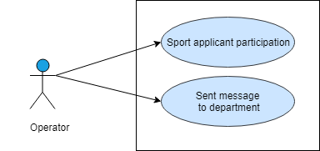

Figure 9: Use case level-1.3 (Communication Management)

## Test specifications (Subsystem: Communication management)

Table 59: Test specifications of T59

|  |  |
| --- | --- |
| **Test case Specification Identifier** | T59 |
| **Purpose** | To check the functionality of ‘Sport applicant participation’ |
| **Test Items Needed** | Refer Usecase-1.3 in SRS |
| **Special Environmental** | Internet should be in working condition. Database software through which the data will be matched should be in running condition. User’s browser should be running properly. |
| **Special Procedural Requirements** | - |
| **Inter-case Dependencies** | - |
| **Input Specifications** | none |
| **Test Procedure** | Press ‘Sport Applicant’ button |
| **Expected Output Specifications** | Show success message |
| **Actual Output** | Show success message |

Table 60: Test specifications of T60

|  |  |
| --- | --- |
| **Test case Specification Identifier** | T60 |
| **Purpose** | To check the functionality of ‘Compose message’ |
| **Test Items Needed** | Refer Usecase-1.3 in SRS |
| **Special Environmental** | Internet should be in working condition. Database software through which the data will be matched should be in running condition. User’s browser should be running properly. |
| **Special Procedural Requirements** | The function ‘Sport applicant participation’ must be executed prior to the current test case |
| **Inter-case Dependencies** | T59 test case must be executed prior to the current test case execution |
| **Input Specifications** | Department name contains character and space within 10 to 40 character,  Game name contains character within 3 to 15 character,  Time of the game contains date and time,  Game details contains text,  Message contains text and  Email contains the department email where operator wants to sent message as given below-  Software Engineering  Cricket  23/11/18 (3.00pm)  Cricket match  Your department is invited to participate in the game  [iit@du.ac.bd](mailto:iit@du.ac.bd) |
| **Test Procedure** | Press ‘Sent message button’ button |
| **Expected Output Specifications** | Show success message |
| **Actual Output** | Show success message |

Table 61: Test specifications of T61

|  |  |
| --- | --- |
| **Test case Specification Identifier** | T61 |
| **Purpose** | To check the functionality of ‘Compose message’ |
| **Test Items Needed** | Refer Usecase-1.3 in SRS |
| **Special Environmental** | Internet should be in working condition. Database software through which the data will be matched should be in running condition. User’s browser should be running properly. |
| **Special Procedural Requirements** | The function ‘Sport applicant participation’ must be executed prior to the current test case |
| **Inter-case Dependencies** | T59 test case must be executed prior to the current test case execution |
| **Input Specifications** | Department name contains number,  Game name contains character within 3 to 15 character,  Time of the game contains date and time,  Game details contains text,  Message contains text and  Email contains the department email where operator wants to sent message as given below-  Software Engineering123462376  Cricket  23/11/18 (3.00pm)  Cricket match  Your department is invited to participate in the game  [iit@du.ac.bd](mailto:iit@du.ac.bd) |
| **Test Procedure** | Press ‘Sent message’ button |
| **Expected Output Specifications** | Show invalid department name message |
| **Actual Output** | Show invalid department name message |

Table 62: Test specifications of T62

|  |  |
| --- | --- |
| **Test case Specification Identifier** | T62 |
| **Purpose** | To check the functionality of ‘Compose message’ |
| **Test Items Needed** | Refer Usecase-1.3 in SRS |
| **Special Environmental** | Internet should be in working condition. Database software through which the data will be matched should be in running condition. User’s browser should be running properly. |
| **Special Procedural Requirements** | The function ‘Sport applicant participation’ must be executed prior to the current test case |
| **Inter-case Dependencies** | T59 test case must be executed prior to the current test case execution |
| **Input Specifications** | Department name contains character and space within 10 to 40 character,  Game name contains number,  Time of the game contains date and time,  Game details contains text,  Message contains text and  Email contains the department email where operator wants to sent message as given below-  Software Engineering  Cricket123445  23/11/18 (3.00pm)  Cricket match  Your department is invited to participate in the game  [iit@du.ac.bd](mailto:iit@du.ac.bd) |
| **Test Procedure** | Press ‘Sent message button’ button |
| **Expected Output Specifications** | Show invalid game name alert message |
| **Actual Output** | Show invalid game name alert message |

Table 63: Test specifications of T63

|  |  |
| --- | --- |
| **Test case Specification Identifier** | T63 |
| **Purpose** | To check the functionality of ‘Compose message’ |
| **Test Items Needed** | Refer Usecase-1.3 in SRS |
| **Special Environmental** | Internet should be in working condition. Database software through which the data will be matched should be in running condition. User’s browser should be running properly. |
| **Special Procedural Requirements** | The function ‘Sport applicant participation’ must be executed prior to the current test case |
| **Inter-case Dependencies** | T59 test case must be executed prior to the current test case execution |
| **Input Specifications** | Department name contains character and space within 10 to 40 character,  Game name contains special character,  Time of the game contains date and time,  Game details contains text,  Message contains text and  Email contains the department email where operator wants to sent message as given below-  Software Engineering  Cricket@#$!  23/11/18 (3.00pm)  Cricket match  Your department is invited to participate in the game  [iit@du.ac.bd](mailto:iit@du.ac.bd) |
| **Test Procedure** | Press ‘Sent message button’ button |
| **Expected Output Specifications** | Show invalid game name alert message |
| **Actual Output** | Show invalid game name alert message |

Table 64: Test specifications of T64

|  |  |
| --- | --- |
| **Test case Specification Identifier** | T64 |
| **Purpose** | To check the functionality of ‘Compose message’ |
| **Test Items Needed** | Refer Usecase-1.3 in SRS |
| **Special Environmental** | Internet should be in working condition. Database software through which the data will be matched should be in running condition. User’s browser should be running properly. |
| **Special Procedural Requirements** | The function ‘Sport applicant participation’ must be executed prior to the current test case |
| **Inter-case Dependencies** | T59 test case must be executed prior to the current test case execution |
| **Input Specifications** | Department name contains character and space within 10 to 40 character,  Game name contains character within 3 to 15 character,  Time of the game contains special character,  Game details contains text,  Message contains text and  Email contains the department email where operator wants to sent message as given below-  Software Engineering  23/11/18 (3.00pm@#$)  Cricket match  Your department is invited to participate in the game  [iit@du.ac.bd](mailto:iit@du.ac.bd) |
| **Test Procedure** | Press ‘Sent message button’ button |
| **Expected Output Specifications** | Show invalid time alert message |
| **Actual Output** | Show invalid time alert message |

Table 65: Test specifications of T65

|  |  |
| --- | --- |
| **Test case Specification Identifier** | T65 |
| **Purpose** | To check the functionality of ‘Compose message’ |
| **Test Items Needed** | Refer Usecase-1.3 in SRS |
| **Special Environmental** | Internet should be in working condition. Database software through which the data will be matched should be in running condition. User’s browser should be running properly. |
| **Special Procedural Requirements** | The function ‘Sport applicant participation’ must be executed prior to the current test case |
| **Inter-case Dependencies** | T59 test case must be executed prior to the current test case execution |
| **Input Specifications** | Department name contains character and space within 10 to 40 character,  Game name contains character within 3 to 15 character,  Time of the game contains date and time,  Game details contains text,  Message contains text and  Email contains the department email(invalid) where operator wants to sent message as given below-  Software Engineering  23/11/18 (3.00pm)  Cricket match  Your department is invited to participate in the game  [eheehnm@com.bd](mailto:eheehnm@com.bd) |
| **Test Procedure** | Press ‘Sent message button’ button |
| **Expected Output Specifications** | Show invalid email alert message |
| **Actual Output** | Show invalid email alert message |

Table 66: Test specifications of T66

|  |  |
| --- | --- |
| **Test case Specification Identifier** | T66 |
| **Purpose** | To check the functionality of ‘Sent message to department’ |
| **Test Items Needed** | Refer Usecase-1.3 in SRS |
| **Special Environmental** | Internet should be in working condition. Database software through which the data will be matched should be in running condition. User’s browser should be running properly. |
| **Special Procedural Requirements** | The function ‘Compose message’ must be executed prior to the current test case |
| **Inter-case Dependencies** | T60 test case must be executed prior to the current test case execution |
| **Input Specifications** | none |
| **Test Procedure** | Press ‘Sent message’ button |
| **Expected Output Specifications** | Show success message |
| **Actual Output** | Show success message |

## Test design specification (Subsystem: Score management)

|  |  |  |  |  |
| --- | --- | --- | --- | --- |
| Serial No. | Functionality | Use case no. in SRS | Test cases | Status |
|  | Score management | 1.4 | T67 | Pass |
|  | Cricket Match | 1.4 | T68 | Pass |
|  | Match management | 1.4.1 | T69,T70,T71,T72,  T73,T74,T75 | Bug found at T71 and T72 |
|  | Score update | 1.4.1 | T76,T77,T78,T79,  T80,T81,T82,T83 | Pass |
|  | Athletic | 1.4 | T84 | Pass |
|  | Insert winner | 1.4.2 | T85,T86,T87,T88,  T89,T90 | Bug found at T88,T89,T90 |
|  | Edit winner | 1.4.2 | T91,T92 | Bug found at T92 |
|  | Remove winner | 1.4.2 | T93 | Pass |
|  | Volleyball | 1.4 | T94 | Pass |
|  | Insert volleyball match details | 1.4.3 | T95,T96,T97,T98,  T99 | Pass |
|  | Edit volleyball match details | 1.4.3 | T100,T101 | Pass |
|  | Remove volleyball match details | 1.4.3 | T102 | Pass |

## Reference Use Cases (Subsystem: Score management)

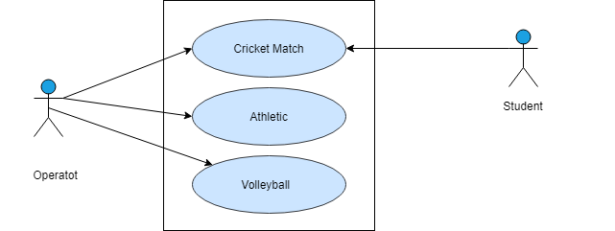

Figure 10: Use case level-1.4 (Score management)

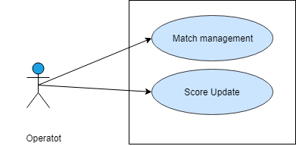

Figure 11: Use case level-1.4.1 (Cricket Match)

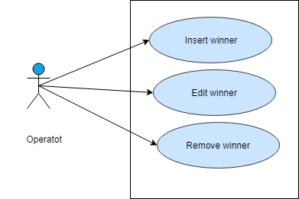

Figure 12: Use case level-1.4.2 (Athletic)

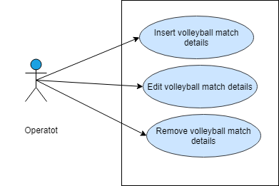

Figure 13: Use case level-1.4.3 (Volleyball)

## Test specifications (Subsystem: Score management)

Table 67: Test specifications of T67

|  |  |
| --- | --- |
| **Test case Specification Identifier** | T67 |
| **Purpose** | To check the functionality of ‘Score management’ |
| **Test Items Needed** | Refer Usecase-1.4 in SRS |
| **Special Environmental** | Internet should be in working condition. Database software through which the data will be matched should be in running condition. User’s browser should be running properly. |
| **Special Procedural Requirements** | - |
| **Inter-case Dependencies** | - |
| **Input Specifications** | none |
| **Test Procedure** | Press ‘Score management’ button |
| **Expected Output Specifications** | Go to score management page |
| **Actual Output** | Go to score management page |

Table 68: Test specifications of T68

|  |  |
| --- | --- |
| **Test case Specification Identifier** | T68 |
| **Purpose** | To check the functionality of ‘Cricket Match’ |
| **Test Items Needed** | Refer Usecase-1.4 in SRS |
| **Special Environmental** | Internet should be in working condition. Database software through which the data will be matched should be in running condition. User’s browser should be running properly. |
| **Special Procedural Requirements** | The function ‘Score Management’ must be executed prior to the current test case |
| **Inter-case Dependencies** | T67 test case must be executed prior to the current test case execution |
| **Input Specifications** | none |
| **Test Procedure** | Press ‘Cricket’ button |
| **Expected Output Specifications** | Go to cricket management page |
| **Actual Output** | Go to cricket management page |

Table 69: Test specifications of T69

|  |  |
| --- | --- |
| **Test case Specification Identifier** | T69 |
| **Purpose** | To check the functionality of ‘Match management’ |
| **Test Items Needed** | Refer Usecase-1.4.1 in SRS |
| **Special Environmental** | Internet should be in working condition. Database software through which the data will be matched should be in running condition. User’s browser should be running properly. |
| **Special Procedural Requirements** | The function ‘Cricket match’ must be executed prior to the current test case |
| **Inter-case Dependencies** | T68 test case must be executed prior to the current test case execution |
| **Input Specifications** | none |
| **Test Procedure** | Press ‘Match Management’ button |
| **Expected Output Specifications** | Go to cricket match management page |
| **Actual Output** | Go to cricket match management page |

Table 70: Test specifications of T70

|  |  |
| --- | --- |
| **Test case Specification Identifier** | T70 |
| **Purpose** | To check the functionality of ‘Match management’ |
| **Test Items Needed** | Refer Usecase-1.4.1 in SRS |
| **Special Environmental** | Internet should be in working condition. Database software through which the data will be matched should be in running condition. User’s browser should be running properly. |
| **Special Procedural Requirements** | The function ‘Cricket match’ must be executed prior to the current test case |
| **Inter-case Dependencies** | T68 test case must be executed prior to the current test case execution |
| **Input Specifications** | Team-1 player name characters only,  Team-2 player name characters only,  toss win team name contains character only,  bating team name contains character as given below-  Team-1… Team-2…  Sabik, Toukir  Sabik, Jubaer  Shashab.. etc. Shihab… etc  Team-1  Team-2 |
| **Test Procedure** | Press ‘Add’ button |
| **Expected Output Specifications** | Show success message |
| **Actual Output** | Show success message |

Table 71Test specifications of T71

|  |  |
| --- | --- |
| **Test case Specification Identifier** | T71 |
| **Purpose** | To check the functionality of ‘Match management’ |
| **Test Items Needed** | Refer Usecase-1.4.1 in SRS |
| **Special Environmental** | Internet should be in working condition. Database software through which the data will be matched should be in running condition. User’s browser should be running properly. |
| **Special Procedural Requirements** | The function ‘Cricket match’ must be executed prior to the current test case |
| **Inter-case Dependencies** | T68 test case must be executed prior to the current test case execution |
| **Input Specifications** | Team-1 player name contains special characters,  Team-2 player name characters only,  toss win team name contains character only,  bating team name contains character as given below-  Team-1… Team-2…  Sabik1243, Toukir  Sabik234, Jubaer  Shashab… etc. Shihab… etc  Team-1  Team-2 |
| **Test Procedure** | Press ‘Add’ button |
| **Expected Output Specifications** | Show invalid name alert message |
| **Actual Output** | Go to cricket match management page |

Table 72: Test specifications of T72

|  |  |
| --- | --- |
| **Test case Specification Identifier** | T72 |
| **Purpose** | To check the functionality of ‘Match management’ |
| **Test Items Needed** | Refer Usecase-1.4.1 in SRS |
| **Special Environmental** | Internet should be in working condition. Database software through which the data will be matched should be in running condition. User’s browser should be running properly. |
| **Special Procedural Requirements** | The function ‘Cricket match’ must be executed prior to the current test case |
| **Inter-case Dependencies** | T68 test case must be executed prior to the current test case execution |
| **Input Specifications** | Team-1 player name contains characters only,  Team-2 player name contains special character,  toss win team name contains character only,  bating team name contains character as given below-  Team-1… Team-2…  Sabik, Toukir@#$  Sabik, Jubaer  Shashab.. etc. Shihab… etc  Team-1  Team-2 |
| **Test Procedure** | Press ‘Add’ button |
| **Expected Output Specifications** | Show invalid name alert message |
| **Actual Output** | Show success message |

Table 73: Test specifications of T73

|  |  |
| --- | --- |
| **Test case Specification Identifier** | T73 |
| **Purpose** | To check the functionality of ‘Match management’ |
| **Test Items Needed** | Refer Usecase-1.4.1 in SRS |
| **Special Environmental** | Internet should be in working condition. Database software through which the data will be matched should be in running condition. User’s browser should be running properly. |
| **Special Procedural Requirements** | The function ‘Cricket match’ must be executed prior to the current test case |
| **Inter-case Dependencies** | T68 test case must be executed prior to the current test case execution |
| **Input Specifications** | Team-1 player name contains characters only,  Team-2 player name contains characters only,  toss win team name contains special character,  bating team name contains character as given below-  Team-1… Team-2…  Sabik, Toukir  Sabik, Jubaer  Shashab.. etc. Shihab… etc  Team-1@#$  Team-2 |
| **Test Procedure** | Press ‘Add’ button |
| **Expected Output Specifications** | Show invalid toss win team name alert |
| **Actual Output** | Show invalid toss win team name alert |

Table 74: Test specifications of T74

|  |  |
| --- | --- |
| **Test case Specification Identifier** | T74 |
| **Purpose** | To check the functionality of ‘Match management’ |
| **Test Items Needed** | Refer Usecase-1.4.1 in SRS |
| **Special Environmental** | Internet should be in working condition. Database software through which the data will be matched should be in running condition. User’s browser should be running properly. |
| **Special Procedural Requirements** | The function ‘Cricket match’ must be executed prior to the current test case |
| **Inter-case Dependencies** | T68 test case must be executed prior to the current test case execution |
| **Input Specifications** | Team-1 player name contains characters only,  Team-2 player name contains characters only,  toss win team name contains number and special character only,  bating team name contains character as given below-  Team-1… Team-2…  Sabik, Toukir  Sabik, Jubaer  Shashab.. etc. Shihab… etc  Team-123#$  Team-2 |
| **Test Procedure** | Press ‘Add’ button |
| **Expected Output Specifications** | Show invalid toss win team name alert |
| **Actual Output** | Show invalid toss win team name alert |

Table 75: Test specifications of T75

|  |  |
| --- | --- |
| **Test case Specification Identifier** | T75 |
| **Purpose** | To check the functionality of ‘Match management’ |
| **Test Items Needed** | Refer Usecase-1.4.1 in SRS |
| **Special Environmental** | Internet should be in working condition. Database software through which the data will be matched should be in running condition. User’s browser should be running properly. |
| **Special Procedural Requirements** | The function ‘Cricket match’ must be executed prior to the current test case |
| **Inter-case Dependencies** | T68 test case must be executed prior to the current test case execution |
| **Input Specifications** | Team-1 player name contains characters only,  Team-2 player name contains characters only,  toss win team name contains character only,  bating team name contains number and special character as given below-  Team-1… Team-2…  Sabik, Toukir  Sabik, Jubaer  Shashab.. .etc. Shihab… etc  Team-1  Team-2@34$% |
| **Test Procedure** | Press ‘Add’ button |
| **Expected Output Specifications** | Show invalid batting team name alert message |
| **Actual Output** | Show invalid batting team name alert message |

Table 76: Test specifications of T76

|  |  |
| --- | --- |
| **Test case Specification Identifier** | T76 |
| **Purpose** | To check the functionality of ‘Match management’ |
| **Test Items Needed** | Refer Usecase-1.4.1 in SRS |
| **Special Environmental** | Internet should be in working condition. Database software through which the data will be matched should be in running condition. User’s browser should be running properly. |
| **Special Procedural Requirements** | The function ‘Cricket match’ must be executed prior to the current test case |
| **Inter-case Dependencies** | T68 test case must be executed prior to the current test case execution |
| **Input Specifications** | Team-1 player name contains characters only,  Team-2 player name contains characters only,  toss win team name contains character only,  bating team name contains number and special character as given below-  Team-1… Team-2…  Sabik, Toukir  Sabik, Jubaer  Shashab.. .etc. Shihab… etc  Team-1  Team-2@34$% |
| **Test Procedure** | Press ‘Add’ button |
| **Expected Output Specifications** | Show invalid batting team name alert message |
| **Actual Output** | Show invalid batting team name alert message |

Table 77: Test specifications of T77

|  |  |
| --- | --- |
| **Test case Specification Identifier** | T77 |
| **Purpose** | To check the functionality of ‘Score update’ |
| **Test Items Needed** | Refer Usecase-1.4.1 in SRS |
| **Special Environmental** | Internet should be in working condition. Database software through which the data will be matched should be in running condition. User’s browser should be running properly. |
| **Special Procedural Requirements** | The function ‘Match management’ must be executed prior to the current test case |
| **Inter-case Dependencies** | T72 test case must be executed prior to the current test case execution |
| **Input Specifications** | Updated score contains number only,  Updated wicket contains number only and  Updated over contains number only as given below-  34  1  2.1 |
| **Test Procedure** | Press ‘update’ button |
| **Expected Output Specifications** | Show success message |
| **Actual Output** | Show success message |

Table 78: Test specifications of T78

|  |  |
| --- | --- |
| **Test case Specification Identifier** | T78 |
| **Purpose** | To check the functionality of ‘Score update’ |
| **Test Items Needed** | Refer Usecase-1.4.1 in SRS |
| **Special Environmental** | Internet should be in working condition. Database software through which the data will be matched should be in running condition. User’s browser should be running properly. |
| **Special Procedural Requirements** | The function ‘Match management’ must be executed prior to the current test case |
| **Inter-case Dependencies** | T72 test case must be executed prior to the current test case execution |
| **Input Specifications** | Updated score contains character only,  Updated wicket contains number only and  Updated over contains number only as given below-  ccc  1  2.1 |
| **Test Procedure** | Press ‘update’ button |
| **Expected Output Specifications** | Show invalid score alert message |
| **Actual Output** | Show invalid score alert message |

Table 79: Test specifications of T79

|  |  |
| --- | --- |
| **Test case Specification Identifier** | T79 |
| **Purpose** | To check the functionality of ‘Score update’ |
| **Test Items Needed** | Refer Usecase-1.4.1 in SRS |
| **Special Environmental** | Internet should be in working condition. Database software through which the data will be matched should be in running condition. User’s browser should be running properly. |
| **Special Procedural Requirements** | The function ‘Match management’ must be executed prior to the current test case |
| **Inter-case Dependencies** | T72 test case must be executed prior to the current test case execution |
| **Input Specifications** | Updated score contains special character only,  Updated wicket contains number only and  Updated over contains number only as given below-  @#$  1  2.1 |
| **Test Procedure** | Press ‘update’ button |
| **Expected Output Specifications** | Show invalid score alert message |
| **Actual Output** | Show invalid score alert message |

Table 80: Test specifications of T80

|  |  |
| --- | --- |
| **Test case Specification Identifier** | T80 |
| **Purpose** | To check the functionality of ‘Score update’ |
| **Test Items Needed** | Refer Usecase-1.4.1 in SRS |
| **Special Environmental** | Internet should be in working condition. Database software through which the data will be matched should be in running condition. User’s browser should be running properly. |
| **Special Procedural Requirements** | The function ‘Match management’ must be executed prior to the current test case |
| **Inter-case Dependencies** | T72 test case must be executed prior to the current test case execution |
| **Input Specifications** | Updated score contains number only,  Updated wicket contains character and  Updated over contains number only as given below-  34  ccc  2.1 |
| **Test Procedure** | Press ‘update’ button |
| **Expected Output Specifications** | Show invalid wicket alert message |
| **Actual Output** | Show invalid wicket alert message |

Table 81: Test specifications of T81

|  |  |
| --- | --- |
| **Test case Specification Identifier** | T81 |
| **Purpose** | To check the functionality of ‘Score update’ |
| **Test Items Needed** | Refer Usecase-1.4.1 in SRS |
| **Special Environmental** | Internet should be in working condition. Database software through which the data will be matched should be in running condition. User’s browser should be running properly. |
| **Special Procedural Requirements** | The function ‘Match management’ must be executed prior to the current test case |
| **Inter-case Dependencies** | T72 test case must be executed prior to the current test case execution |
| **Input Specifications** | Updated score contains number only,  Updated wicket contains special character and  Updated over contains number only as given below-  34  @#$%!  2.1 |
| **Test Procedure** | Press ‘update’ button |
| **Expected Output Specifications** | Show invalid wicket alert message |
| **Actual Output** | Show invalid wicket alert message |

Table 82: Test specifications of T75

|  |  |
| --- | --- |
| **Test case Specification Identifier** | T82 |
| **Purpose** | To check the functionality of ‘Score update’ |
| **Test Items Needed** | Refer Usecase-1.4.1 in SRS |
| **Special Environmental** | Internet should be in working condition. Database software through which the data will be matched should be in running condition. User’s browser should be running properly. |
| **Special Procedural Requirements** | The function ‘Match management’ must be executed prior to the current test case |
| **Inter-case Dependencies** | T72 test case must be executed prior to the current test case execution |
| **Input Specifications** | Updated score contains number only,  Updated wicket contains number only and  Updated over contains character only as given below-  34  1  2ccc |
| **Test Procedure** | Press ‘update’ button |
| **Expected Output Specifications** | Show invalid over alert message |
| **Actual Output** | Show invalid over alert message |

Table 83: Test specifications of T83

|  |  |
| --- | --- |
| **Test case Specification Identifier** | T83 |
| **Purpose** | To check the functionality of ‘Score update’ |
| **Test Items Needed** | Refer Usecase-1.4.1 in SRS |
| **Special Environmental** | Internet should be in working condition. Database software through which the data will be matched should be in running condition. User’s browser should be running properly. |
| **Special Procedural Requirements** | The function ‘Match management’ must be executed prior to the current test case |
| **Inter-case Dependencies** | T72 test case must be executed prior to the current test case execution |
| **Input Specifications** | Updated score contains number only,  Updated wicket contains number only and  Updated over contains special only as given below-  34  1  2@#$ |
| **Test Procedure** | Press ‘update’ button |
| **Expected Output Specifications** | Show invalid over alert message |
| **Actual Output** | Show invalid over alert message |

Table 84: Test specifications of T84

|  |  |
| --- | --- |
| **Test case Specification Identifier** | T84 |
| **Purpose** | To check the functionality of ‘Athletic’ |
| **Test Items Needed** | Refer Usecase-1.4 in SRS |
| **Special Environmental** | Internet should be in working condition. Database software through which the data will be matched should be in running condition. User’s browser should be running properly. |
| **Special Procedural Requirements** | - |
| **Inter-case Dependencies** | - |
| **Input Specifications** | none |
| **Test Procedure** | Press ‘Athletic’ button |
| **Expected Output Specifications** | Go to athletic management page |
| **Actual Output** | Go to athletic management page |

Table 85: Test specifications of T85

|  |  |
| --- | --- |
| **Test case Specification Identifier** | T85 |
| **Purpose** | To check the functionality of ‘insert winner’ |
| **Test Items Needed** | Refer Usecase-1.4.2 in SRS |
| **Special Environmental** | Internet should be in working condition. Database software through which the data will be matched should be in running condition. User’s browser should be running properly. |
| **Special Procedural Requirements** | The function ‘Athletic’ must be executed prior to the current test case |
| **Inter-case Dependencies** | T84 test case must be executed prior to the current test case execution |
| **Input Specifications** | Hall name contains character only,  Sport name contains character only,  Rank1 contains character only,  Rank2 contains character only and  Rank3 contains character only  Sufia Kamal Hall  Race Competition  Mina  Sabina  Tumpa |
| **Test Procedure** | Press ‘insert’ button |
| **Expected Output Specifications** | Show success message |
| **Actual Output** | Show success message |

Table 86: Test specifications of T86

|  |  |
| --- | --- |
| **Test case Specification Identifier** | T86 |
| **Purpose** | To check the functionality of ‘insert winner’ |
| **Test Items Needed** | Refer Usecase-1.4.2 in SRS |
| **Special Environmental** | Internet should be in working condition. Database software through which the data will be matched should be in running condition. User’s browser should be running properly. |
| **Special Procedural Requirements** | The function ‘Athletic’ must be executed prior to the current test case |
| **Inter-case Dependencies** | T84 test case must be executed prior to the current test case execution |
| **Input Specifications** | Hall name contains number and special character only,  Sport name contains character only,  Rank1 contains character only,  Rank2 contains character only and  Rank3 contains character only  Sufia Kamal Hall123@#  Race Competition  Mina  Sabina  Tumpa |
| **Test Procedure** | Press ‘insert’ button |
| **Expected Output Specifications** | Show invalid hall name alert message |
| **Actual Output** | Show invalid hall name alert message |

Table 87: Test specifications of T87

|  |  |
| --- | --- |
| **Test case Specification Identifier** | T87 |
| **Purpose** | To check the functionality of ‘insert winner’ |
| **Test Items Needed** | Refer Usecase-1.4.2 in SRS |
| **Special Environmental** | Internet should be in working condition. Database software through which the data will be matched should be in running condition. User’s browser should be running properly. |
| **Special Procedural Requirements** | The function ‘Athletic’ must be executed prior to the current test case |
| **Inter-case Dependencies** | T84 test case must be executed prior to the current test case execution |
| **Input Specifications** | Hall name contains character only,  Sport name contains number and special character only,  Rank1 contains character only,  Rank2 contains character only and  Rank3 contains character only  Sufia Kamal Hall  Race Competition123@#$  Mina  Sabina  Tumpa |
| **Test Procedure** | Press ‘insert’ button |
| **Expected Output Specifications** | Show invalid sport name alert message |
| **Actual Output** | Show invalid sport name alert message |

Table 88: Test specifications of T88

|  |  |
| --- | --- |
| **Test case Specification Identifier** | T88 |
| **Purpose** | To check the functionality of ‘insert winner’ |
| **Test Items Needed** | Refer Usecase-1.4.2 in SRS |
| **Special Environmental** | Internet should be in working condition. Database software through which the data will be matched should be in running condition. User’s browser should be running properly. |
| **Special Procedural Requirements** | The function ‘Athletic’ must be executed prior to the current test case |
| **Inter-case Dependencies** | T84 test case must be executed prior to the current test case execution |
| **Input Specifications** | Hall name contains character only,  Sport name contains character only,  Rank1 contains number only,  Rank2 contains character only and  Rank3 contains character only  Sufia Kamal Hall  Race Competition  Mina123  Sabina  Tumpa |
| **Test Procedure** | Press ‘insert’ button |
| **Expected Output Specifications** | Show invalid rank1 alert message |
| **Actual Output** | Show success message |

Table 89: Test specifications of T89

|  |  |
| --- | --- |
| **Test case Specification Identifier** | T89 |
| **Purpose** | To check the functionality of ‘insert winner’ |
| **Test Items Needed** | Refer Usecase-1.4.2 in SRS |
| **Special Environmental** | Internet should be in working condition. Database software through which the data will be matched should be in running condition. User’s browser should be running properly. |
| **Special Procedural Requirements** | The function ‘Athletic’ must be executed prior to the current test case |
| **Inter-case Dependencies** | T84 test case must be executed prior to the current test case execution |
| **Input Specifications** | Hall name contains character only,  Sport name contains character only,  Rank1 contains character only,  Rank2 contains number only and  Rank3 contains character only  Sufia Kamal Hall  Race Competition  Mina  Sabina123  Tumpa |
| **Test Procedure** | Press ‘insert’ button |
| **Expected Output Specifications** | Show invalid rank2 alert message |
| **Actual Output** | Show success message |

Table 90: Test specifications of T90

|  |  |
| --- | --- |
| **Test case Specification Identifier** | T90 |
| **Purpose** | To check the functionality of ‘insert winner’ |
| **Test Items Needed** | Refer Usecase-1.4.2 in SRS |
| **Special Environmental** | Internet should be in working condition. Database software through which the data will be matched should be in running condition. User’s browser should be running properly. |
| **Special Procedural Requirements** | The function ‘Athletic’ must be executed prior to the current test case |
| **Inter-case Dependencies** | T84 test case must be executed prior to the current test case execution |
| **Input Specifications** | Hall name contains character only,  Sport name contains character only,  Rank1 contains character only,  Rank2 contains character only and  Rank3 contains number only  Sufia Kamal Hall  Race Competition  Mina  Sabina  Tumpa123 |
| **Test Procedure** | Press ‘insert’ button |
| **Expected Output Specifications** | Show invalid rank3 alert message |
| **Actual Output** | Show success message |

Table 91: Test specifications of T91

|  |  |
| --- | --- |
| **Test case Specification Identifier** | T91 |
| **Purpose** | To check the functionality of ‘edit winner’ |
| **Test Items Needed** | Refer Usecase-1.4.2 in SRS |
| **Special Environmental** | Internet should be in working condition. Database software through which the data will be matched should be in running condition. User’s browser should be running properly. |
| **Special Procedural Requirements** | The function ‘Athletic’ must be executed prior to the current test case |
| **Inter-case Dependencies** | T84 test case must be executed prior to the current test case execution |
| **Input Specifications** | Hall name contains character only,  Sport name contains character only,  Rank1 contains character only,  Rank2 contains character only and  Rank3 contains character only  Sufia Kamal Hall  Race Competition  Mina  Sabina  Tumpa |
| **Test Procedure** | Press ‘update’ button |
| **Expected Output Specifications** | Show success message |
| **Actual Output** | Show success message |

Table 92: Test specifications of T92

|  |  |
| --- | --- |
| **Test case Specification Identifier** | T92 |
| **Purpose** | To check the functionality of ‘edit winner’ |
| **Test Items Needed** | Refer Usecase-1.4.2 in SRS |
| **Special Environmental** | Internet should be in working condition. Database software through which the data will be matched should be in running condition. User’s browser should be running properly. |
| **Special Procedural Requirements** | The function ‘Athletic’ must be executed prior to the current test case |
| **Inter-case Dependencies** | T84 test case must be executed prior to the current test case execution |
| **Input Specifications** | Hall name contains character only,  Sport name contains character only,  Rank1 contains number,  Rank2 contains number and  Rank3 contains number  Sufia Kamal Hall  Race Competition  Mina1213  Sabina123  Tumpa112 |
| **Test Procedure** | Press ‘update’ button |
| **Expected Output Specifications** | Show invalid rank alert message |
| **Actual Output** | Show success message |

Table 93: Test specifications of T93

|  |  |
| --- | --- |
| **Test case Specification Identifier** | T93 |
| **Purpose** | To check the functionality of ‘Volleyball’ |
| **Test Items Needed** | Refer Usecase-1.4 in SRS |
| **Special Environmental** | Internet should be in working condition. Database software through which the data will be matched should be in running condition. User’s browser should be running properly. |
| **Special Procedural Requirements** | The function ‘Score Management’ must be executed prior to the current test case |
| **Inter-case Dependencies** | T67 test case must be executed prior to the current test case execution |
| **Input Specifications** | none |
| **Test Procedure** | Press ‘Volleyball’ button |
| **Expected Output Specifications** | Go to volleyball management page |
| **Actual Output** | Go to volleyball management page |

Table 94: Test specifications of T94

|  |  |
| --- | --- |
| **Test case Specification Identifier** | T94 |
| **Purpose** | To check the functionality of ‘insert volleyball details’ |
| **Test Items Needed** | Refer Usecase-1.4 in SRS |
| **Special Environmental** | Internet should be in working condition. Database software through which the data will be matched should be in running condition. User’s browser should be running properly. |
| **Special Procedural Requirements** | The function ‘Volleyball’ must be executed prior to the current test case |
| **Inter-case Dependencies** | T93 test case must be executed prior to the current test case execution |
| **Input Specifications** | Winning team name contains character,  Losing team name contain character and  Man of the match contains character as given below-  Team1  Team2  Sabik |
| **Test Procedure** | Press ‘insert’ button |
| **Expected Output Specifications** | Show success message |
| **Actual Output** | Show success message |

Table 95: Test specifications of T95

|  |  |
| --- | --- |
| **Test case Specification Identifier** | T95 |
| **Purpose** | To check the functionality of ‘insert volleyball details’ |
| **Test Items Needed** | Refer Usecase-1.4 in SRS |
| **Special Environmental** | Internet should be in working condition. Database software through which the data will be matched should be in running condition. User’s browser should be running properly. |
| **Special Procedural Requirements** | The function ‘Volleyball’ must be executed prior to the current test case |
| **Inter-case Dependencies** | T93 test case must be executed prior to the current test case execution |
| **Input Specifications** | Winning team name contains special character,  Losing team name contain character and  Man of the match contains character as given below-  Team@#$$1  Team2  Sabik |
| **Test Procedure** | Press ‘insert’ button |
| **Expected Output Specifications** | Show invalid team name alert message |
| **Actual Output** | Show invalid team name alert message |

Table 96: Test specifications of T96

|  |  |
| --- | --- |
| **Test case Specification Identifier** | T96 |
| **Purpose** | To check the functionality of ‘insert volleyball details’ |
| **Test Items Needed** | Refer Usecase-1.4 in SRS |
| **Special Environmental** | Internet should be in working condition. Database software through which the data will be matched should be in running condition. User’s browser should be running properly. |
| **Special Procedural Requirements** | The function ‘Volleyball’ must be executed prior to the current test case |
| **Inter-case Dependencies** | T93 test case must be executed prior to the current test case execution |
| **Input Specifications** | Winning team name contains character,  Losing team name contain special character and  Man of the match contains character as given below-  Team1  Team$$&!2  Sabik |
| **Test Procedure** | Press ‘insert’ button |
| **Expected Output Specifications** | Show invalid team name alert message |
| **Actual Output** | Show invalid team name alert message |

Table 97: Test specifications of T97

|  |  |
| --- | --- |
| **Test case Specification Identifier** | T97 |
| **Purpose** | To check the functionality of ‘insert volleyball details’ |
| **Test Items Needed** | Refer Usecase-1.4 in SRS |
| **Special Environmental** | Internet should be in working condition. Database software through which the data will be matched should be in running condition. User’s browser should be running properly. |
| **Special Procedural Requirements** | The function ‘Volleyball’ must be executed prior to the current test case |
| **Inter-case Dependencies** | T93 test case must be executed prior to the current test case execution |
| **Input Specifications** | Winning team name contains character,  Losing team name contain character and  Man of the match contains special character and number as given below-  Team1  Team2  Sabik#$$123 |
| **Test Procedure** | Press ‘insert’ button |
| **Expected Output Specifications** | Show invalid man of the match name alert message |
| **Actual Output** | Show invalid man of the match name alert message |

Table 98: Test specifications of T98

|  |  |
| --- | --- |
| **Test case Specification Identifier** | T98 |
| **Purpose** | To check the functionality of ‘edit volleyball details’ |
| **Test Items Needed** | Refer Usecase-1.4 in SRS |
| **Special Environmental** | Internet should be in working condition. Database software through which the data will be matched should be in running condition. User’s browser should be running properly. |
| **Special Procedural Requirements** | The function ‘Volleyball’ must be executed prior to the current test case |
| **Inter-case Dependencies** | T93 test case must be executed prior to the current test case execution |
| **Input Specifications** | Winning team name contains character,  Losing team name contain character and  Man of the match contains character as given below-  Team1  Team2  Sabik |
| **Test Procedure** | Press ‘update’ button |
| **Expected Output Specifications** | Show success message |
| **Actual Output** | Show success message |

Table 99: Test specifications of T99

|  |  |
| --- | --- |
| **Test case Specification Identifier** | T99 |
| **Purpose** | To check the functionality of ‘edit volleyball details’ |
| **Test Items Needed** | Refer Usecase-1.4 in SRS |
| **Special Environmental** | Internet should be in working condition. Database software through which the data will be matched should be in running condition. User’s browser should be running properly. |
| **Special Procedural Requirements** | The function ‘Volleyball’ must be executed prior to the current test case |
| **Inter-case Dependencies** | T93 test case must be executed prior to the current test case execution |
| **Input Specifications** | Winning team name contains special character,  Losing team name contain character and  Man of the match contains character as given below-  Team1@#$  Team2  Sabik |
| **Test Procedure** | Press ‘update’ button |
| **Expected Output Specifications** | Show invalid team name alert message |
| **Actual Output** | Show invalid team name alert message |

Table 100: Test specifications of T100

|  |  |
| --- | --- |
| **Test case Specification Identifier** | T100 |
| **Purpose** | To check the functionality of ‘edit volleyball details’ |
| **Test Items Needed** | Refer Usecase-1.4 in SRS |
| **Special Environmental** | Internet should be in working condition. Database software through which the data will be matched should be in running condition. User’s browser should be running properly. |
| **Special Procedural Requirements** | The function ‘Volleyball’ must be executed prior to the current test case |
| **Inter-case Dependencies** | T93 test case must be executed prior to the current test case execution |
| **Input Specifications** | Winning team name contains character,  Losing team name contain special character and  Man of the match contains character as given below-  Team1  Team%@#$2  Sabik |
| **Test Procedure** | Press ‘update’ button |
| **Expected Output Specifications** | Show invalid team name alert message |
| **Actual Output** | Show invalid team name alert message |

Table 101: Test specifications of T101

|  |  |
| --- | --- |
| **Test case Specification Identifier** | T101 |
| **Purpose** | To check the functionality of ‘edit volleyball details’ |
| **Test Items Needed** | Refer Usecase-1.4 in SRS |
| **Special Environmental** | Internet should be in working condition. Database software through which the data will be matched should be in running condition. User’s browser should be running properly. |
| **Special Procedural Requirements** | The function ‘Volleyball’ must be executed prior to the current test case |
| **Inter-case Dependencies** | T93 test case must be executed prior to the current test case execution |
| **Input Specifications** | Winning team name contains character,  Losing team name contain character and  Man of the match contains special character and number as given below-  Team1  Team2  Sabik |
| **Test Procedure** | Press ‘update’ button |
| **Expected Output Specifications** | Show invalid man of the match name alert message |
| **Actual Output** | Show invalid man of the match name alert message |

Table 102: Test specifications of T102

|  |  |
| --- | --- |
| **Test case Specification Identifier** | T102 |
| **Purpose** | To check the functionality of ‘Remove volleyball details’ |
| **Test Items Needed** | Refer Usecase-1.4 in SRS |
| **Special Environmental** | Internet should be in working condition. Database software through which the data will be matched should be in running condition. User’s browser should be running properly. |
| **Special Procedural Requirements** | The function ‘Volleyball’ must be executed prior to the current test case |
| **Inter-case Dependencies** | T93 test case must be executed prior to the current test case execution |
| **Input Specifications** | none |
| **Test Procedure** | Press ‘remove’ button |
| **Expected Output Specifications** | Show success message |
| **Actual Output** | Show success message |